UNITED STATES
SECURITIES AND EXCHANGE COMMISSION
WASHINGTON, D.C. 20549
FORM |  |  | 8-K
CURRENT REPORT
Pursuant to Section 13 or 15(d) of the Securities Exchange Act of 1934
Date of report (Date of earliest event reported): August 14, 2026
PILGRIM'S PRIDE CORPORATION
(Exact Name of registrant as specified in its charter)
Delaware |  |  |  |  |  | 1-9273 |  |  |  |  |  | 75-1285071
(State or other jurisdiction of  incorporation or organization) |  |  |  |  |  | (Commission File Number) |  |  |  |  |  | (IRS Employer Identification No.)
1770 Promontory Circle |  |  |  |  |  |  |  |  | 80634-9038
Greeley |  |  | CO |  |  |  |  |  | (Zip Code)
(Address of principal executive offices)
Registrant's telephone number, including area code: (970) 506-8000
Not Applicable
(Former name or former address, if changed since last report.)
Check the appropriate box below if the Form 8-K filing is intended to simultaneously satisfy the filing obligation of the registrant under any of the following provisions:
☐ Written communications pursuant to Rule 425 under the Securities Act (17 CFR 230.425)
☐ Soliciting material pursuant to Rule 14a-12 under the Exchange Act (17 CFR 240.14a-12)
☐ Pre-commencement communications pursuant to Rule 14d-2(b) under the Exchange Act (17 CFR 240.14d-2(b))
☐ Pre-commencement communications pursuant to Rule 13e-4(c) under the Exchange Act (17 CFR 240.13e-4(c))
Securities registered pursuant to Section 12(b) of the Act:
Title of each class |  |  |  |  |  | Trading Symbol |  |  |  |  |  | Name of Exchange on Which Registered
Common Stock, Par Value $0.01 |  |  |  |  |  | PPC |  |  |  |  |  | The Nasdaq Stock Market LLC
Indicate by check mark whether the registrant is an emerging growth company as defined in as defined in Rule 405 of the Securities Act of 1933 (§230.405 of this chapter) or Rule 12b-2 of the Securities Exchange Act of 1934 (§240.12b-2 of this chapter).
Emerging growth company |  |  | ☐
If an emerging growth company, indicate by check mark if the registrant has elected not to use the extended transition period for complying with any new or revised financial accounting standards provided pursuant to Section 13(a) of the Exchange Act. ☐

Item 1.01 Entry into a Material Definitive Agreement.
On August 14, 2026, Pilgrim’s Pride Corporation (“Company”), through its subsidiary Onix Investments UK Limited, entered into a Share Purchase Agreement (the “Agreement”) with Walker’s Deli & Sausage Company (“Walker’s”) from Samworth Brothers Limited (“Seller”), pursuant to which the Company will acquire the entire issued share capital of Walker’s from Seller. Walkers specializes in the manufacturing of premium sausages, cooked meats, bacon, snacking products, and pâté. The Company is also currently a supplier of some of Walkers’ raw pork.
Under the terms of the Agreement, the total consideration is approximately £141.5 million, on a debt-free, cash-free basis, subject to certain routine closing adjustments. The consideration will be paid fully in cash on completion (the “Closing”), when Walkers will become a wholly-owned subsidiary of the Company. The Agreement contains warranties and covenants of the Seller and the Company customary for a transaction of this type. The Agreement also contains certain indemnities given by the Seller for the purposes of allocating contractual risk and certain specified pensions, employment, tax, and other general matters relating to Walker’s. Subject to certain limitations and conditions set forth in the Agreement, the Seller and the Company will be responsible to each other from and after Closing for, among other things, certain breaches or inaccuracies of the warranties, covenants, and indemnities contained in the Agreement.
Closing is anticipated to occur in September 2026, subject to customary closing conditions, including approval by the U.K. Competition and Markets Authority (CMA) and completion of employee consultation obligations under applicable U.K. law. The Closing is not subject to a financing condition. The Agreement contains certain customary termination rights, including regulatory, financial, and operational triggers.
The foregoing description of the Agreement does not purport to be complete and is qualified in its entirety by reference to the full text of the Agreement, a copy of which the Company will file as an exhibit to its upcoming Quarterly Report on Form 10-Q for the period ending September 27, 2026. The representations, warranties, and covenants contained in the Agreement were made solely for purposes of the Agreement and as of specific dates, were solely for the benefit of the parties to the Agreement, and may be subject to limitations agreed upon by the parties, including being qualified by confidential disclosures made by each party to the other for the purposes of allocating contractual risk between them that differ from those applicable to investors. Certain representations and warranties may be subject to a contractual standard of materiality different from those generally applicable to investors, and may have been used for the purpose of allocating risk between the parties rather than establishing matters as facts. Information concerning the subject matter of the representations, warranties, and covenants may change after the date of the Agreement, which subsequent information may or may not be fully reflected in public disclosures by the Company. Investors should not rely on the representations, warranties, and covenants or any description thereof as characterizations of the actual state of facts or condition of the Company.

Item 7.01 Regulation FD Disclosure.
On August 17, 2026, the Company issued a press release announcing the signing of the Agreement, attached hereto as Exhibit 99.1 and incorporated herein by reference. The information furnished in Item 7.01 and in Exhibit 99.1 shall not be deemed “filed” for purposes of Section 18 of the Securities Exchange Act of 1934, as amended (the “Exchange Act”), or incorporated by reference in any of the Company’s filings under the Securities Act of 1933, as amended, or the Exchange Act.

Item 9.01 Financial Statements and Exhibits.
(d) Exhibits
Exhibit No. |  |  |  |  |  | Description
99.1 |  |  |  |  |  | Press Release issued by the Company dated August 17, 2026.
104 |  |  |  |  |  | Cover Page Interactive Data File (formatted as Inline XBRL and contained in Exhibit 101)

SIGNATURES
Pursuant to the requirements of the Securities Exchange Act of 1934, the registrant has duly caused this report to be signed on its behalf by the undersigned hereunto duly authorized.
 |  |  |  |  |  |  |  |  | PILGRIM’S PRIDE CORPORATION
Date: |  |  | August 17, 2026 |  |  |  |  |  | /s/ Matthew Galvanoni
 |  |  |  |  |  |  |  |  | Matthew Galvanoni
 |  |  |  |  |  |  |  |  | Chief Financial Officer and Chief Accounting Officer
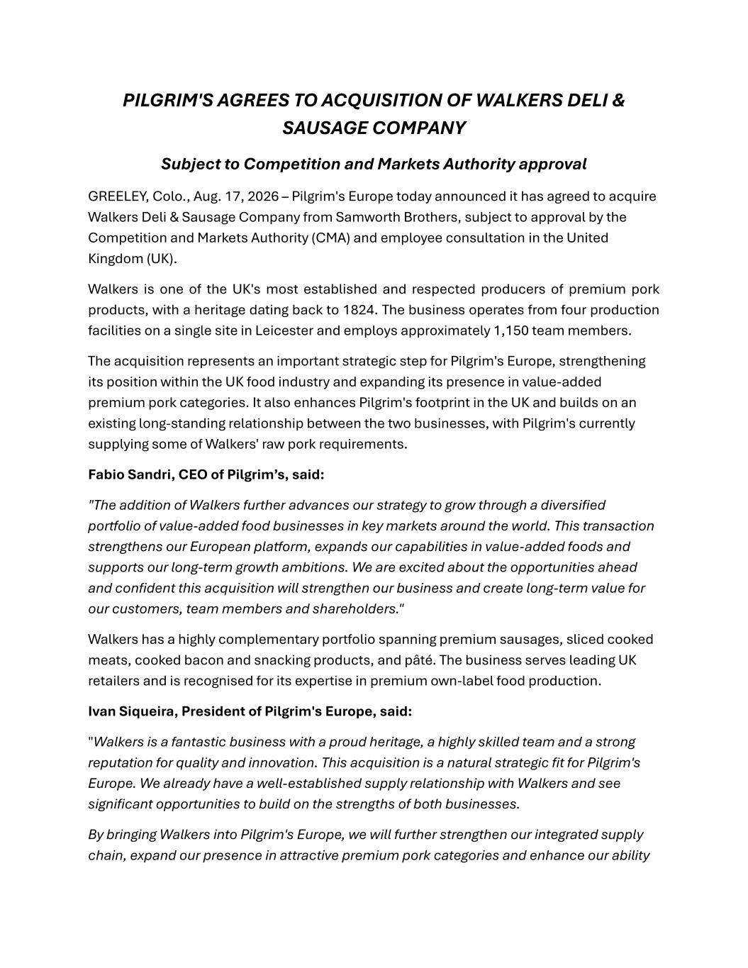

PILGRIM'S AGREES TO ACQUISITION OF WALKERS DELI & SAUSAGE COMPANY Subject to Competition and Markets Authority approval GREELEY, Colo., Aug. 17, 2026 – Pilgrim's Europe today announced it has agreed to acquire Walkers Deli & Sausage Company from Samworth Brothers, subject to approval by the Competition and Markets Authority (CMA) and employee consultation in the United Kingdom (UK). Walkers is one of the UK's most established and respected producers of premium pork products, with a heritage dating back to 1824. The business operates from four production facilities on a single site in Leicester and employs approximately 1,150 team members. The acquisition represents an important strategic step for Pilgrim's Europe, strengthening its position within the UK food industry and expanding its presence in value-added premium pork categories. It also enhances Pilgrim's footprint in the UK and builds on an existing long-standing relationship between the two businesses, with Pilgrim's currently supplying some of Walkers' raw pork requirements. Fabio Sandri, CEO of Pilgrim’s, said: "The addition of Walkers further advances our strategy to grow through a diversified portfolio of value-added food businesses in key markets around the world. This transaction strengthens our European platform, expands our capabilities in value-added foods and supports our long-term growth ambitions. We are excited about the opportunities ahead and confident this acquisition will strengthen our business and create long-term value for our customers, team members and shareholders." Walkers has a highly complementary portfolio spanning premium sausages, sliced cooked meats, cooked bacon and snacking products, and pâté. The business serves leading UK retailers and is recognised for its expertise in premium own-label food production. Ivan Siqueira, President of Pilgrim's Europe, said: "Walkers is a fantastic business with a proud heritage, a highly skilled team and a strong reputation for quality and innovation. This acquisition is a natural strategic fit for Pilgrim's Europe. We already have a well-established supply relationship with Walkers and see significant opportunities to build on the strengths of both businesses. By bringing Walkers into Pilgrim's Europe, we will further strengthen our integrated supply chain, expand our presence in attractive premium pork categories and enhance our ability

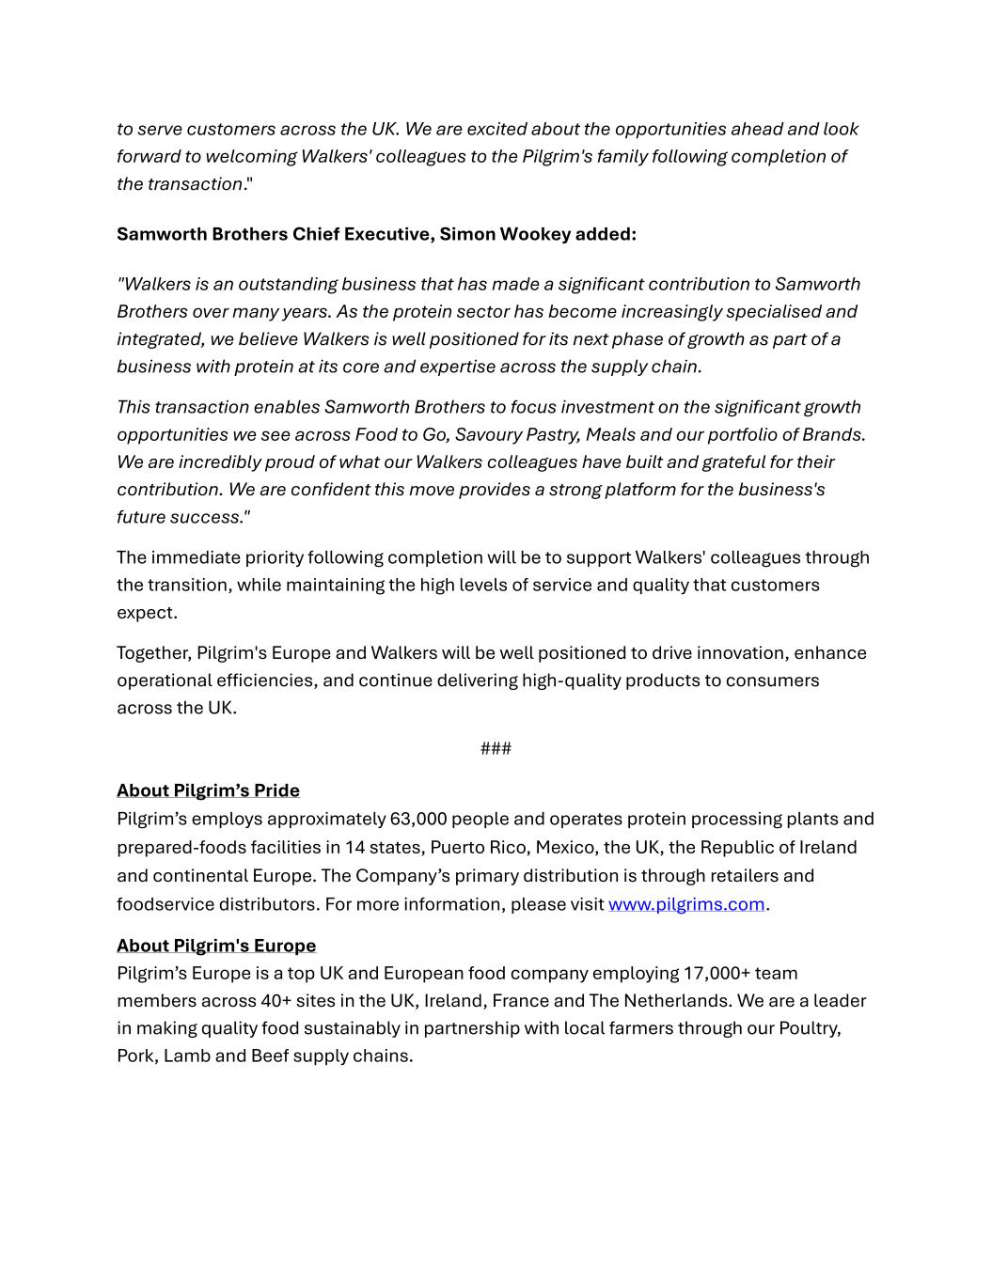
to serve customers across the UK. We are excited about the opportunities ahead and look forward to welcoming Walkers' colleagues to the Pilgrim's family following completion of the transaction." Samworth Brothers Chief Executive, Simon Wookey added: "Walkers is an outstanding business that has made a significant contribution to Samworth Brothers over many years. As the protein sector has become increasingly specialised and integrated, we believe Walkers is well positioned for its next phase of growth as part of a business with protein at its core and expertise across the supply chain. This transaction enables Samworth Brothers to focus investment on the significant growth opportunities we see across Food to Go, Savoury Pastry, Meals and our portfolio of Brands. We are incredibly proud of what our Walkers colleagues have built and grateful for their contribution. We are confident this move provides a strong platform for the business's future success." The immediate priority following completion will be to support Walkers' colleagues through the transition, while maintaining the high levels of service and quality that customers expect. Together, Pilgrim's Europe and Walkers will be well positioned to drive innovation, enhance operational efficiencies, and continue delivering high-quality products to consumers across the UK. ### About Pilgrim’s Pride Pilgrim’s employs approximately 63,000 people and operates protein processing plants and prepared-foods facilities in 14 states, Puerto Rico, Mexico, the UK, the Republic of Ireland and continental Europe. The Company’s primary distribution is through retailers and foodservice distributors. For more information, please visit www.pilgrims.com. About Pilgrim's Europe Pilgrim’s Europe is a top UK and European food company employing 17,000+ team members across 40+ sites in the UK, Ireland, France and The Netherlands. We are a leader in making quality food sustainably in partnership with local farmers through our Poultry, Pork, Lamb and Beef supply chains.

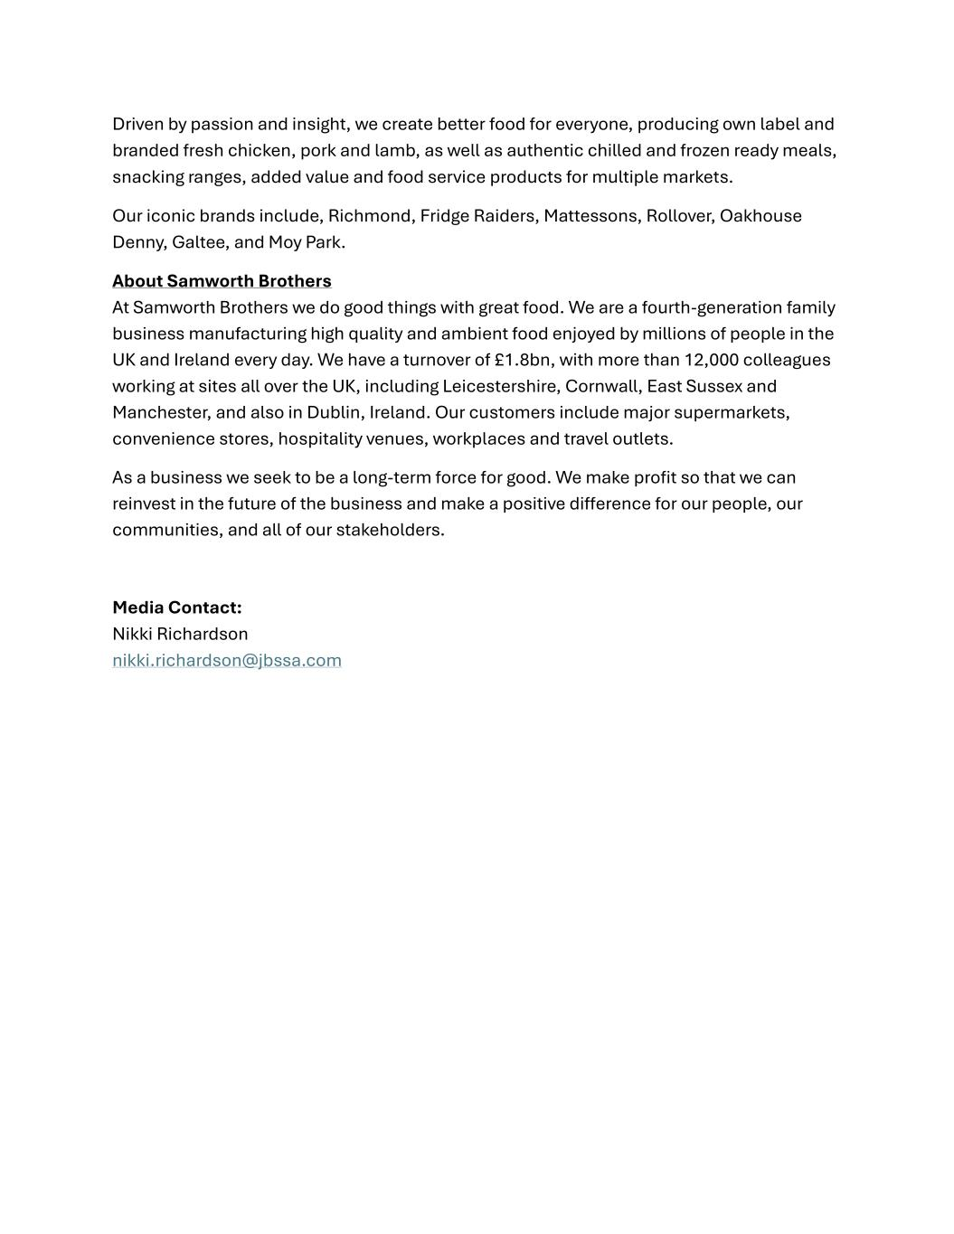
Driven by passion and insight, we create better food for everyone, producing own label and branded fresh chicken, pork and lamb, as well as authentic chilled and frozen ready meals, snacking ranges, added value and food service products for multiple markets. Our iconic brands include, Richmond, Fridge Raiders, Mattessons, Rollover, Oakhouse Denny, Galtee, and Moy Park. About Samworth Brothers At Samworth Brothers we do good things with great food. We are a fourth-generation family business manufacturing high quality and ambient food enjoyed by millions of people in the UK and Ireland every day. We have a turnover of £1.8bn, with more than 12,000 colleagues working at sites all over the UK, including Leicestershire, Cornwall, East Sussex and Manchester, and also in Dublin, Ireland. Our customers include major supermarkets, convenience stores, hospitality venues, workplaces and travel outlets. As a business we seek to be a long-term force for good. We make profit so that we can reinvest in the future of the business and make a positive difference for our people, our communities, and all of our stakeholders. Media Contact: Nikki Richardson nikki.richardson@jbssa.com

