UNITED STATES
SECURITIES AND EXCHANGE COMMISSION
WASHINGTON, D.C. 20549
FORM |  |  | 8-K
CURRENT REPORT
Pursuant to Section 13 or 15(d) of the Securities Exchange Act of 1934
Date of report (Date of earliest event reported): July 29, 2026
PILGRIM'S PRIDE CORPORATION
(Exact Name of registrant as specified in its charter)
Delaware |  |  |  |  |  | 1-9273 |  |  |  |  |  | 75-1285071
(State or other jurisdiction of  incorporation or organization) |  |  |  |  |  | (Commission File Number) |  |  |  |  |  | (IRS Employer Identification No.)
1770 Promontory Circle |  |  |  |  |  |  |  |  | 80634-9038
Greeley |  |  | CO |  |  |  |  |  | (Zip Code)
(Address of principal executive offices)
Registrant's telephone number, including area code: (970) 506-8000
Securities registered pursuant to Section 12(b) of the Act:
Title of each class |  |  |  |  |  | Trading Symbol |  |  |  |  |  | Name of Exchange on Which Registered
Common Stock, Par Value $0.01 |  |  |  |  |  | PPC |  |  |  |  |  | The Nasdaq Stock Market LLC
Not Applicable
(Former name or former address, if changed since last report.)
Check the appropriate box below if the Form 8-K filing is intended to simultaneously satisfy the filing obligation of the registrant under any of the following provisions:
☐ Written communications pursuant to Rule 425 under the Securities Act (17 CFR 230.425)
☐ Soliciting material pursuant to Rule 14a-12 under the Exchange Act (17 CFR 240.14a-12)
☐ Pre-commencement communications pursuant to Rule 14d-2(b) under the Exchange Act (17 CFR 240.14d-2(b))
☐ Pre-commencement communications pursuant to Rule 13e-4(c) under the Exchange Act (17 CFR 240.13e-4(c))
Indicate by check mark whether the registrant is an emerging growth company as defined in Rule 405 of the Securities Act of 1933 (§230.405 of this chapter) or Rule 12b-2 of the Securities Exchange Act of 1934 (§240.12b-2 of this chapter).
Emerging growth company |  |  | ☐
If an emerging growth company, indicate by check mark if the registrant has elected not to use the extended transition period for complying with any new or revised financial accounting standards provided pursuant to Section 13(a) of the Exchange Act. ☐

Item 7.01. Regulation FD Disclosure.
Attached hereto as Exhibit 99.1 is an overview of Pilgrim's Pride Corporation to be referenced during the Company's earnings conference call of July 30, 2026.
The information furnished in Item 7.01 and in Exhibit 99.1 shall not be deemed "filed" for purposes of Section 18 of the Securities Exchange Act of 1934, as amended (the "Exchange Act"), or incorporated by reference in any of Pilgrim's Pride Corporation's filings under the Securities Act of 1933, as amended, or the Exchange Act.

Item 9.01 Financial Statements and Exhibits.
Exhibit 99.1 Supplemental Historical Financial Information
Exhibit 104 Cover Page Interactive Data File formatted in iXBRL

SIGNATURE
Pursuant to the requirements of the Securities Exchange Act of 1934, the registrant has duly caused this report to be signed on its behalf by the undersigned hereunto duly authorized.
 |  |  |  |  |  |  |  |  | PILGRIM’S PRIDE CORPORATION
Date: |  |  | July 29, 2026 |  |  |  |  |  | /s/ Matthew Galvanoni
 |  |  |  |  |  |  |  |  | Matthew Galvanoni
 |  |  |  |  |  |  |  |  | Chief Financial Officer and Chief Accounting Officer


Financial Results For The Second Quarter Ended June 28th 2026 Pilgrim’s Pride Corporation (NASDAQ: PPC)

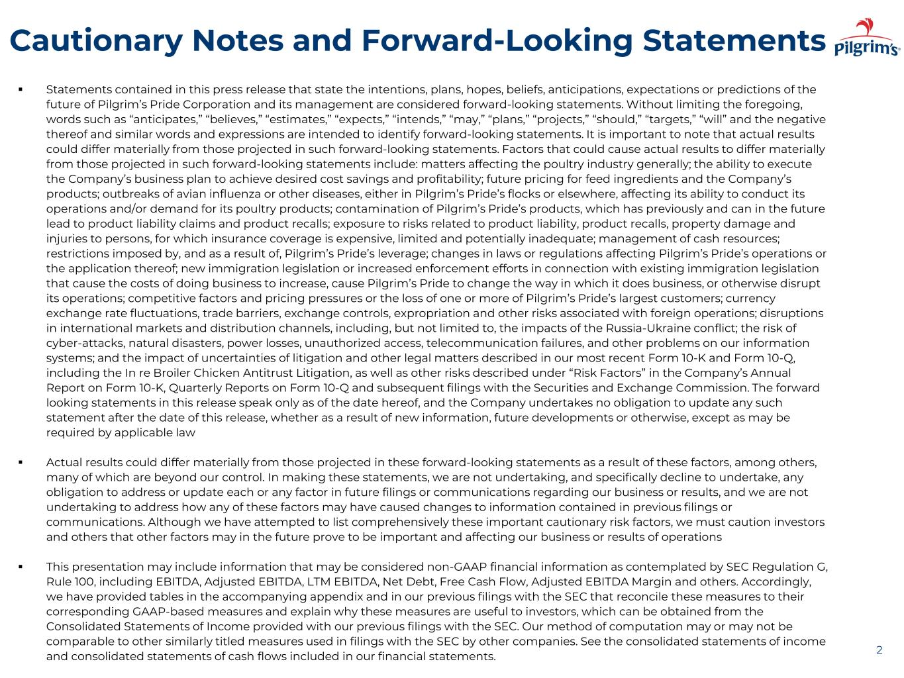
Cautionary Notes and Forward-Looking Statements ▪ Statements contained in this press release that state the intentions, plans, hopes, beliefs, anticipations, expectations or predictions of the future of Pilgrim’s Pride Corporation and its management are considered forward-looking statements. Without limiting the foregoing, words such as “anticipates,” “believes,” “estimates,” “expects,” “intends,” “may,” “plans,” “projects,” “should,” “targets,” “will” and the negative thereof and similar words and expressions are intended to identify forward-looking statements. It is important to note that actual results could differ materially from those projected in such forward-looking statements. Factors that could cause actual results to differ materially from those projected in such forward-looking statements include: matters affecting the poultry industry generally; the ability to execute the Company’s business plan to achieve desired cost savings and profitability; future pricing for feed ingredients and the Company’s products; outbreaks of avian influenza or other diseases, either in Pilgrim’s Pride’s flocks or elsewhere, affecting its ability to conduct its operations and/or demand for its poultry products; contamination of Pilgrim’s Pride’s products, which has previously and can in the future lead to product liability claims and product recalls; exposure to risks related to product liability, product recalls, property damage and injuries to persons, for which insurance coverage is expensive, limited and potentially inadequate; management of cash resources; restrictions imposed by, and as a result of, Pilgrim’s Pride’s leverage; changes in laws or regulations affecting Pilgrim’s Pride’s operations or the application thereof; new immigration legislation or increased enforcement efforts in connection with existing immigration legislation that cause the costs of doing business to increase, cause Pilgrim’s Pride to change the way in which it does business, or otherwise disrupt its operations; competitive factors and pricing pressures or the loss of one or more of Pilgrim’s Pride’s largest customers; currency exchange rate fluctuations, trade barriers, exchange controls, expropriation and other risks associated with foreign operations; disruptions in international markets and distribution channels, including, but not limited to, the impacts of the Russia-Ukraine conflict; the risk of cyber-attacks, natural disasters, power losses, unauthorized access, telecommunication failures, and other problems on our information systems; and the impact of uncertainties of litigation and other legal matters described in our most recent Form 10-K and Form 10-Q, including the In re Broiler Chicken Antitrust Litigation, as well as other risks described under “Risk Factors” in the Company’s Annual Report on Form 10-K, Quarterly Reports on Form 10-Q and subsequent filings with the Securities and Exchange Commission. The forward looking statements in this release speak only as of the date hereof, and the Company undertakes no obligation to update any such statement after the date of this release, whether as a result of new information, future developments or otherwise, except as may be required by applicable law ▪ Actual results could differ materially from those projected in these forward-looking statements as a result of these factors, among others, many of which are beyond our control. In making these statements, we are not undertaking, and specifically decline to undertake, any obligation to address or update each or any factor in future filings or communications regarding our business or results, and we are not undertaking to address how any of these factors may have caused changes to information contained in previous filings or communications. Although we have attempted to list comprehensively these important cautionary risk factors, we must caution investors and others that other factors may in the future prove to be important and affecting our business or results of operations ▪ This presentation may include information that may be considered non-GAAP financial information as contemplated by SEC Regulation G, Rule 100, including EBITDA, Adjusted EBITDA, LTM EBITDA, Net Debt, Free Cash Flow, Adjusted EBITDA Margin and others. Accordingly, we have provided tables in the accompanying appendix and in our previous filings with the SEC that reconcile these measures to their corresponding GAAP-based measures and explain why these measures are useful to investors, which can be obtained from the Consolidated Statements of Income provided with our previous filings with the SEC. Our method of computation may or may not be comparable to other similarly titled measures used in filings with the SEC by other companies. See the consolidated statements of income and consolidated statements of cash flows included in our financial statements. 2

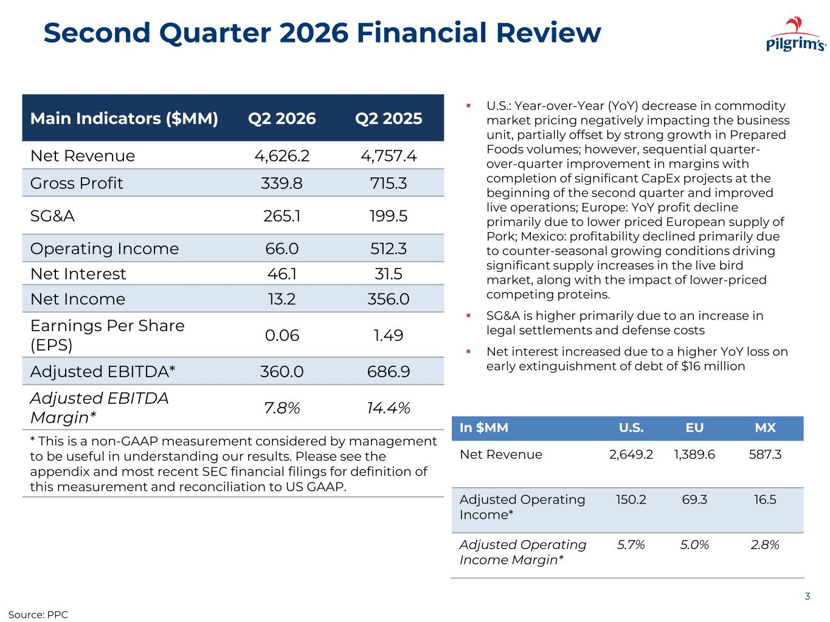
Second Quarter 2026 Financial Review 3 Main Indicators ($MM) Q2 2026 Q2 2025 Net Revenue 4,626.2 4,757.4 Gross Profit 339.8 715.3 SG&A 265.1 199.5 Operating Income 66.0 512.3 Net Interest 46.1 31.5 Net Income 13.2 356.0 Earnings Per Share (EPS) 0.06 1.49 Adjusted EBITDA* 360.0 686.9 Adjusted EBITDA Margin* 7.8% 14.4% * This is a non-GAAP measurement considered by management to be useful in understanding our results. Please see the appendix and most recent SEC financial filings for definition of this measurement and reconciliation to US GAAP. ▪ U.S.: Year-over-Year (YoY) decrease in commodity market pricing negatively impacting the business unit, partially offset by strong growth in Prepared Foods volumes; however, sequential quarter- over-quarter improvement in margins with completion of significant CapEx projects at the beginning of the second quarter and improved live operations; Europe: YoY profit decline primarily due to lower priced European supply of Pork; Mexico: profitability declined primarily due to counter-seasonal growing conditions driving significant supply increases in the live bird market, along with the impact of lower-priced competing proteins. ▪ SG&A is higher primarily due to an increase in legal settlements and defense costs ▪ Net interest increased due to a higher YoY loss on early extinguishment of debt of $16 million In $MM U.S. EU MX Net Revenue 2,649.2 1,389.6 587.3 Adjusted Operating Income* 150.2 69.3 16.5 Adjusted Operating Income Margin* 5.7% 5.0% 2.8% Source: PPC

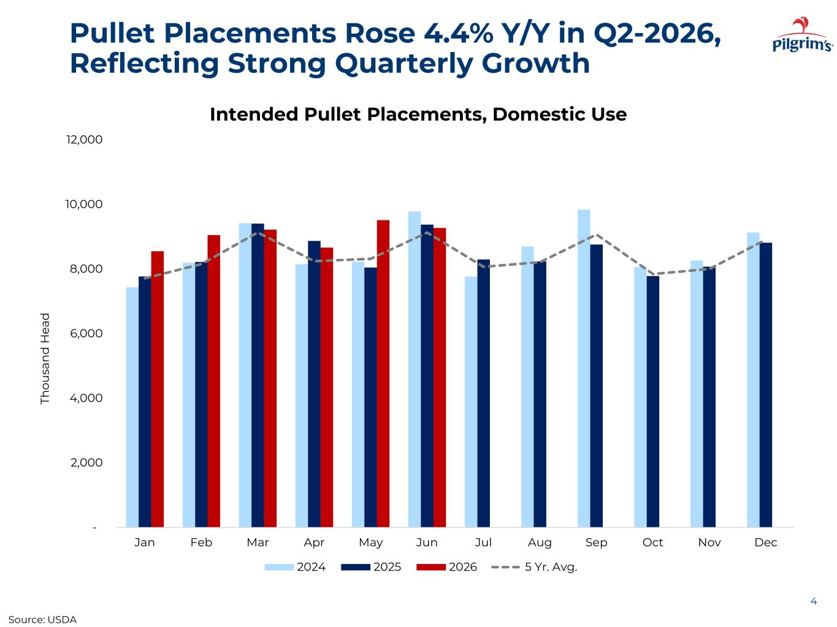
Pullet Placements Rose 4.4% Y/Y in Q2-2026, Reflecting Strong Quarterly Growth 4 - 2,000 4,000 6,000 8,000 10,000 12,000 Jan Feb Mar Apr May Jun Jul Aug Sep Oct Nov Dec Th ou sa n d H ea d Intended Pullet Placements, Domestic Use 2024 2025 2026 5 Yr. Avg. Source: USDA

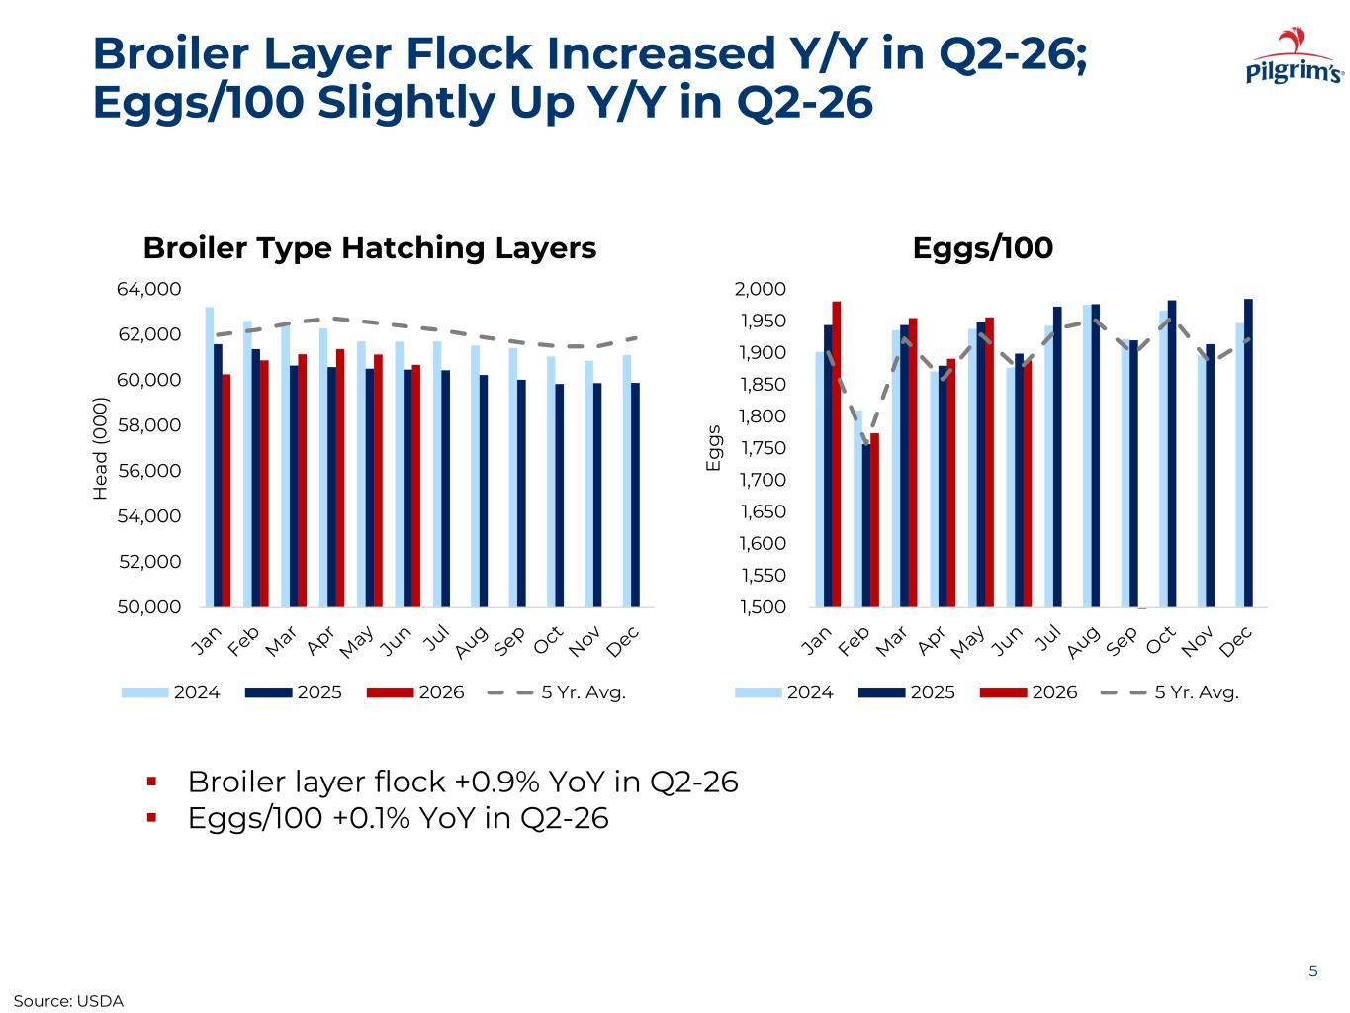
Broiler Layer Flock Increased Y/Y in Q2-26; Eggs/100 Slightly Up Y/Y in Q2-26 5 ▪ Broiler layer flock +0.9% YoY in Q2-26 ▪ Eggs/100 +0.1% YoY in Q2-26 50,000 52,000 54,000 56,000 58,000 60,000 62,000 64,000 H ea d (0 0 0 ) Broiler Type Hatching Layers 2024 2025 2026 5 Yr. Avg. 1,500 1,550 1,600 1,650 1,700 1,750 1,800 1,850 1,900 1,950 2,000 E g g s Eggs/100 2024 2025 2026 5 Yr. Avg. Source: USDA

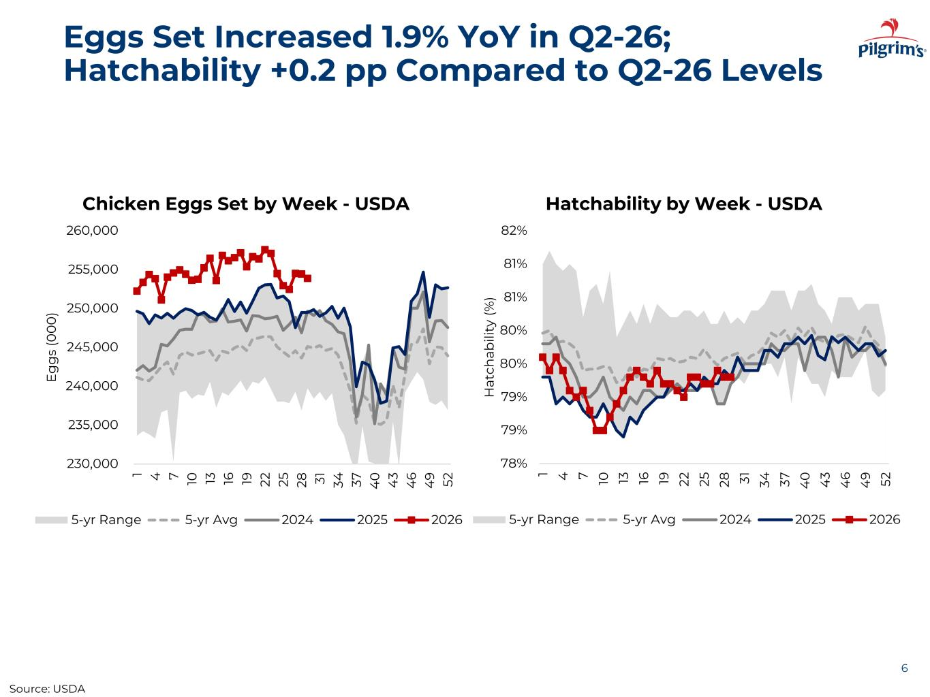
Eggs Set Increased 1.9% YoY in Q2-26; Hatchability +0.2 pp Compared to Q2-26 Levels 6 215,000 220,000 225,000 230,000 235,000 240,000 245,000 250,000 255,000 1 4 7 10 13 16 19 22 25 28 31 34 37 40 43 46 49 52 Eg gs (0 00 ) Chicken Eggs Set by Week - USDA 5-yr Range 5-yr Avg 2023 2024 2025 230,000 235,000 240,000 245,000 250,000 255,00 260,000 1 4 7 10 13 16 19 22 25 28 31 34 37 4 0 4 3 4 6 4 9 52 E g g s (0 0 0 ) Chicken Egg y ek - USDA 5-yr Range 5-yr Avg 2024 2025 2026 78% 79% 79% 80% 80% 81% 81% 82% 1 4 7 10 13 16 19 22 25 28 31 34 37 4 0 4 3 4 6 4 9 52 H at ch ab ili ty (% ) Hatchability by Week - USDA 5-yr Range 5-yr Avg 2024 2025 2026 Source: USDA

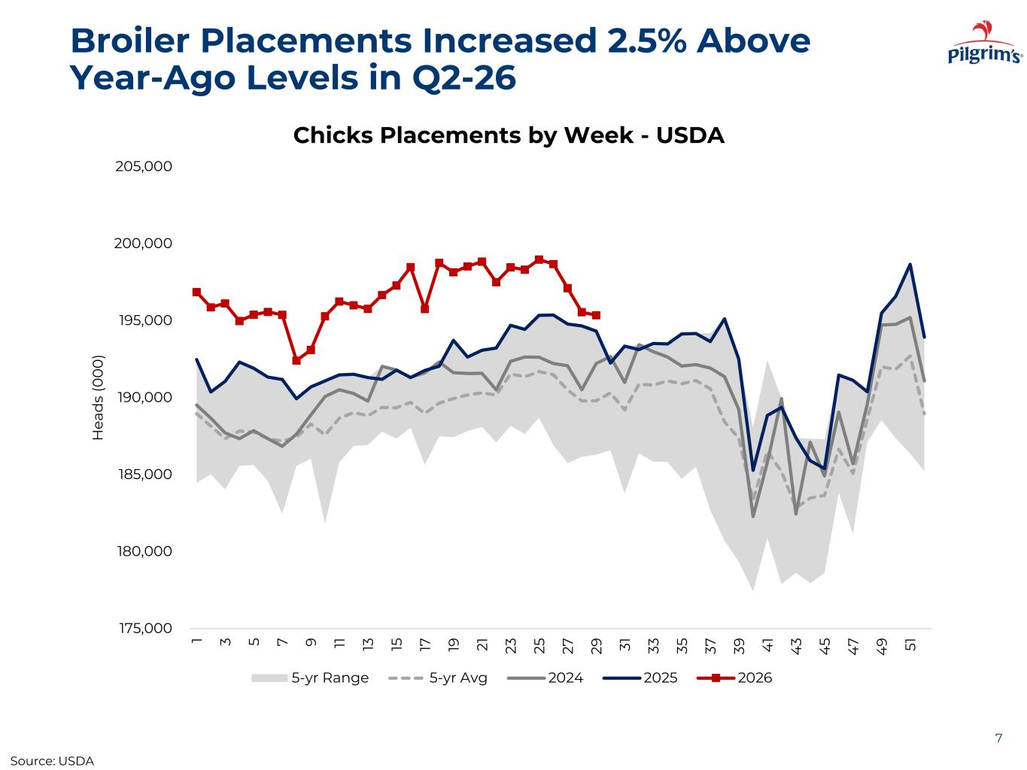
Broiler Placements Increased 2.5% Above Year-Ago Levels in Q2-26 7 175,000 180,000 185,000 190,000 195,000 200,000 205,000 1 3 5 7 9 11 13 15 17 19 21 23 25 27 29 31 33 35 37 39 4 1 4 3 4 5 4 7 4 9 51 H ea d s (0 0 0 ) Chicks Placements by Week - USDA 5-yr Range 5-yr Avg 2024 2025 2026 Source: USDA

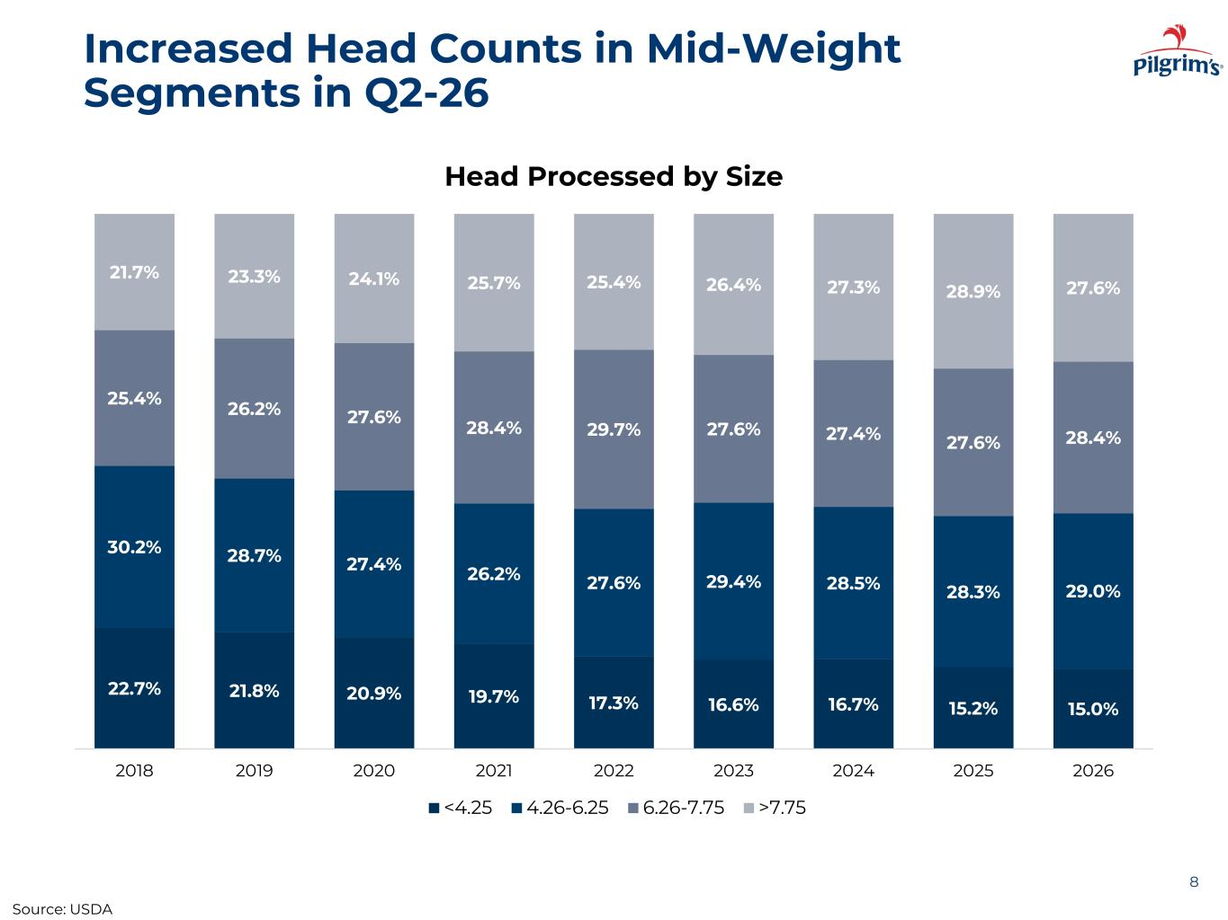
Increased Head Counts in Mid-Weight Segments in Q2-26 8 22.7% 21.8% 20.9% 19.7% 17.3% 16.6% 16.7% 15.2% 15.0% 30.2% 28.7% 27.4% 26.2% 27.6% 29.4% 28.5% 28.3% 29.0% 25.4% 26.2% 27.6% 28.4% 29.7% 27.6% 27.4% 27.6% 28.4% 21.7% 23.3% 24.1% 25.7% 25.4% 26.4% 27.3% 28.9% 27.6% 2018 2019 2020 2021 2022 2023 2024 2025 2026 Head Processed by Size <4.25 4.26-6.25 6.26-7.75 >7.75 Source: USDA

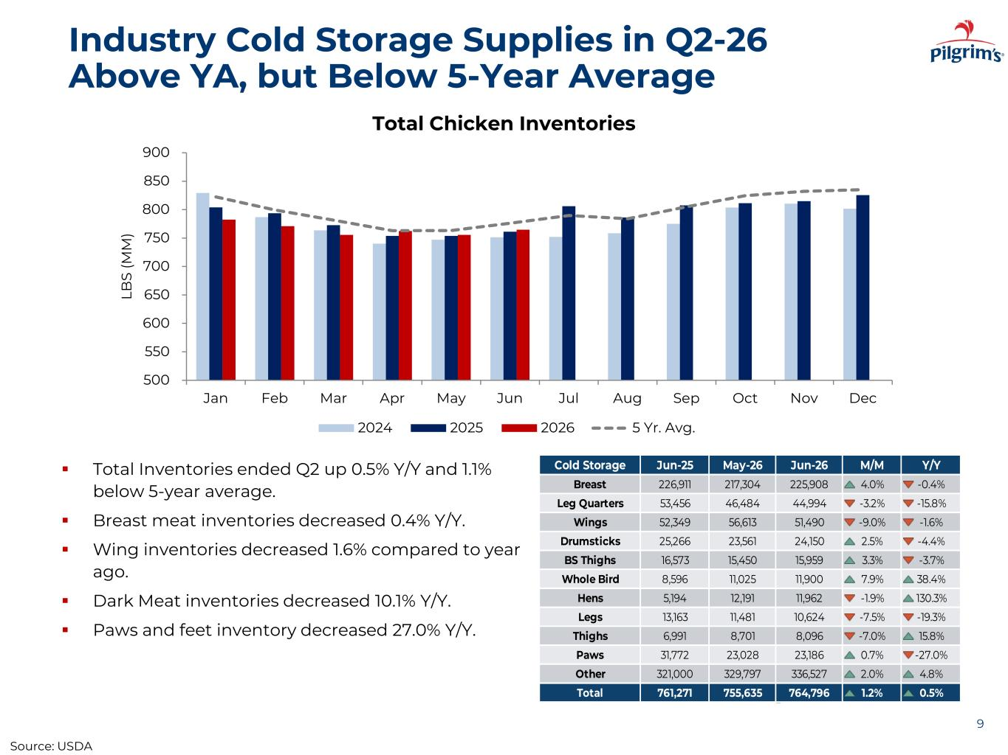
Industry Cold Storage Supplies in Q2-26 Above YA, but Below 5-Year Average ▪ Total Inventories ended Q2 up 0.5% Y/Y and 1.1% below 5-year average. ▪ Breast meat inventories decreased 0.4% Y/Y. ▪ Wing inventories decreased 1.6% compared to year ago. ▪ Dark Meat inventories decreased 10.1% Y/Y. ▪ Paws and feet inventory decreased 27.0% Y/Y. 9 500 550 600 650 700 750 800 850 900 Jan Feb Mar Apr May Jun Jul Aug Sep Oct Nov Dec LB S (M M ) Total Chicken Inventories 2024 2025 2026 5 Yr. Avg. Cold Storage Jun-25 May-26 Jun-26 M/M Y/Y Breast 226,911 217,304 225,908 4.0% -0.4% Leg Quarters 53,456 46,484 44,994 -3.2% -15.8% Wings 52,349 56,613 51,490 -9.0% -1.6% Drumsticks 25,266 23,561 24,150 2.5% -4.4% BS Thighs 16,573 15,450 15,959 3.3% -3.7% Whole Bird 8,596 11,025 11,900 7.9% 38.4% Hens 5,194 12,191 11,962 -1.9% 130.3% Legs 13,163 11,481 10,624 -7.5% -19.3% Thighs 6,991 8,701 8,096 -7.0% 15.8% Paws 31,772 23,028 23,186 0.7% -27.0% Other 321,000 329,797 336,527 2.0% 4.8% Total 761,271 755,635 764,796 1.2% 0.5% Source: USDA

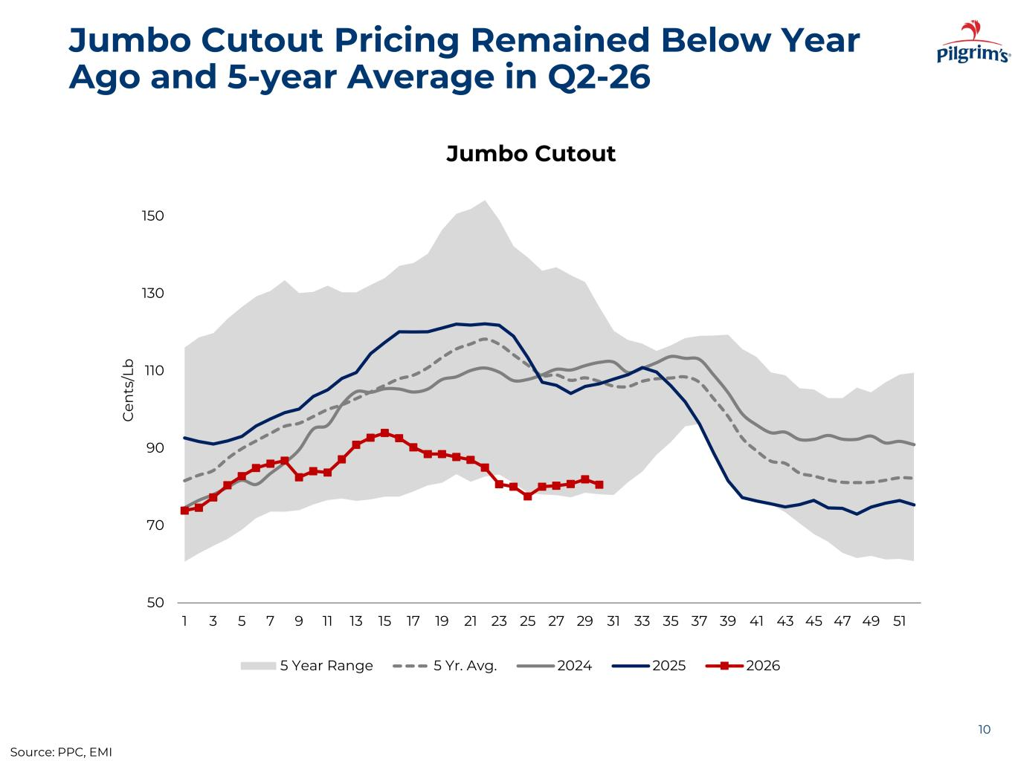
Jumbo Cutout Pricing Remained Below Year Ago and 5-year Average in Q2-26 10 50 70 90 110 130 150 1 3 5 7 9 11 13 15 17 19 21 23 25 27 29 31 33 35 37 39 41 43 45 47 49 51 C en ts /L b Jumbo Cutout 5 Year Range 5 Yr. Avg. 2024 2025 2026 Source: PPC, EMI

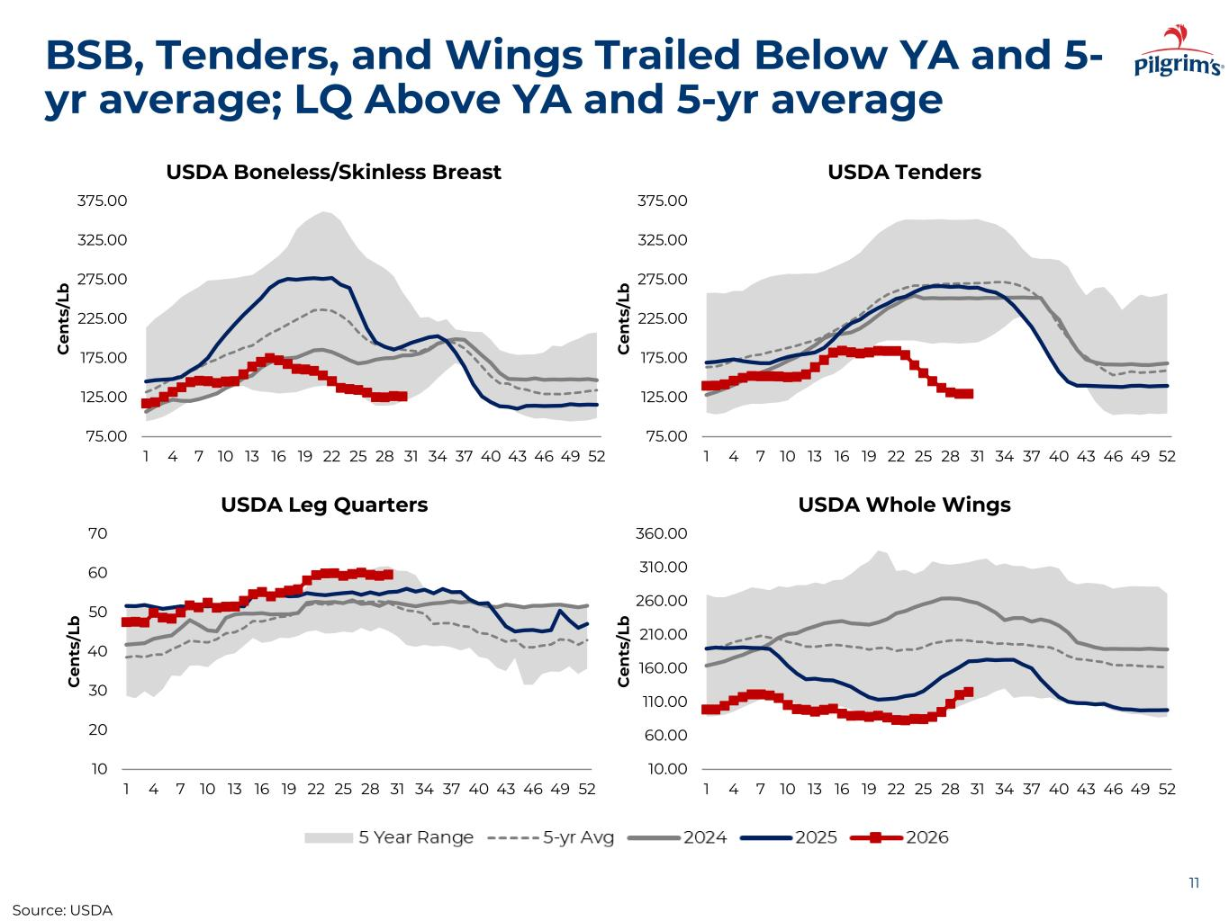
BSB, Tenders, and Wings Trailed Below YA and 5- yr average; LQ Above YA and 5-yr average 11 75.00 125.00 175.00 225.00 275.00 325.00 375.00 1 4 7 10 13 16 19 22 25 28 31 34 37 40 43 46 49 52 C en ts /L b USDA Boneless/Skinless Breast 75.00 125.00 175.00 225.00 275.00 325.00 375.00 1 4 7 10 13 16 19 22 25 28 31 34 37 40 43 46 49 52 C en ts /L b USDA Tenders 10 20 30 40 50 60 70 1 4 7 10 13 16 19 22 25 28 31 34 37 40 43 46 49 52 C en ts /L b USDA Leg Quarters 10.00 60.00 110.00 160.00 210.00 260.00 310.00 360.00 1 4 7 10 13 16 19 22 25 28 31 34 37 40 43 46 49 52 C en ts /L b USDA Whole Wings Source: USDA

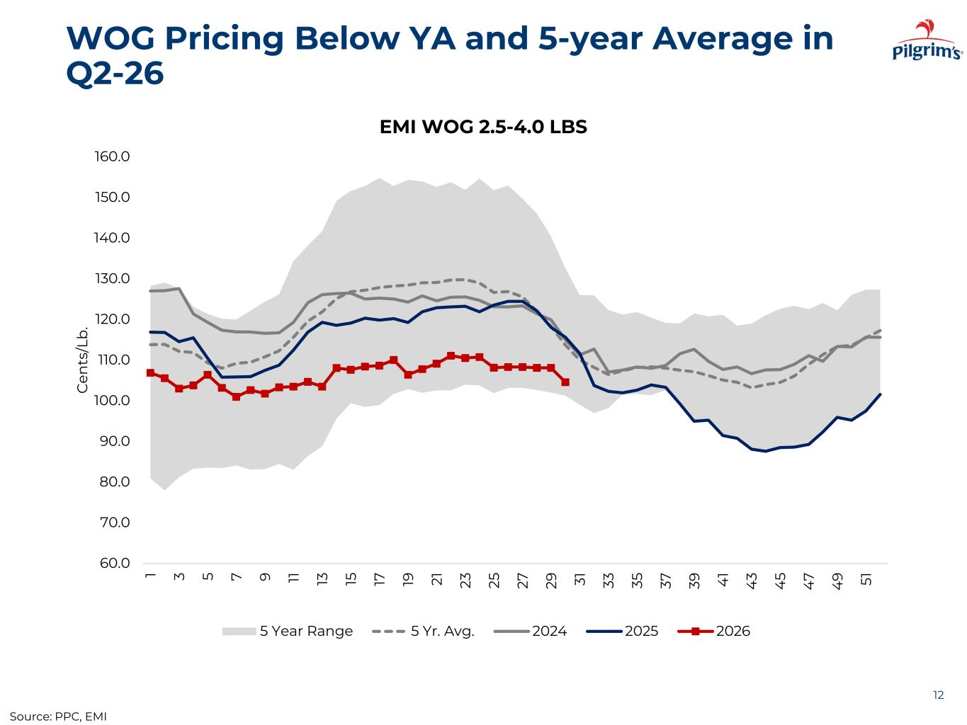
WOG Pricing Below YA and 5-year Average in Q2-26 12 60.0 70.0 80.0 90.0 100.0 110.0 120.0 130.0 140.0 150.0 160.0 1 3 5 7 9 11 13 15 17 19 21 23 25 27 29 31 33 35 37 39 4 1 4 3 4 5 4 7 4 9 51 C en ts /L b . EMI WOG 2.5-4.0 LBS 5 Year Range 5 Yr. Avg. 2024 2025 2026 Source: PPC, EMI

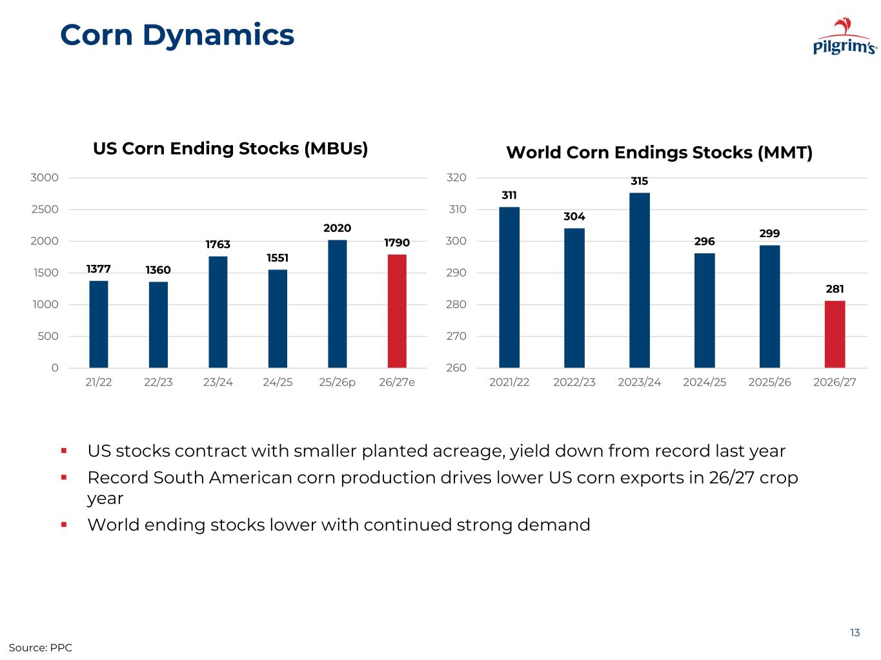
Corn Dynamics 13 Source: PPC ▪ US stocks contract with smaller planted acreage, yield down from record last year ▪ Record South American corn production drives lower US corn exports in 26/27 crop year ▪ World ending stocks lower with continued strong demand 1377 1360 1763 1551 2020 1790 0 500 1000 1500 2000 2500 3000 21/22 22/23 23/24 24/25 25/26p 26/27e US Corn Ending Stocks (MBUs) 311 304 315 296 299 281 260 270 280 290 300 310 320 2021/22 2022/23 2023/24 2024/25 2025/26 2026/27 World Corn Endings Stocks (MMT)

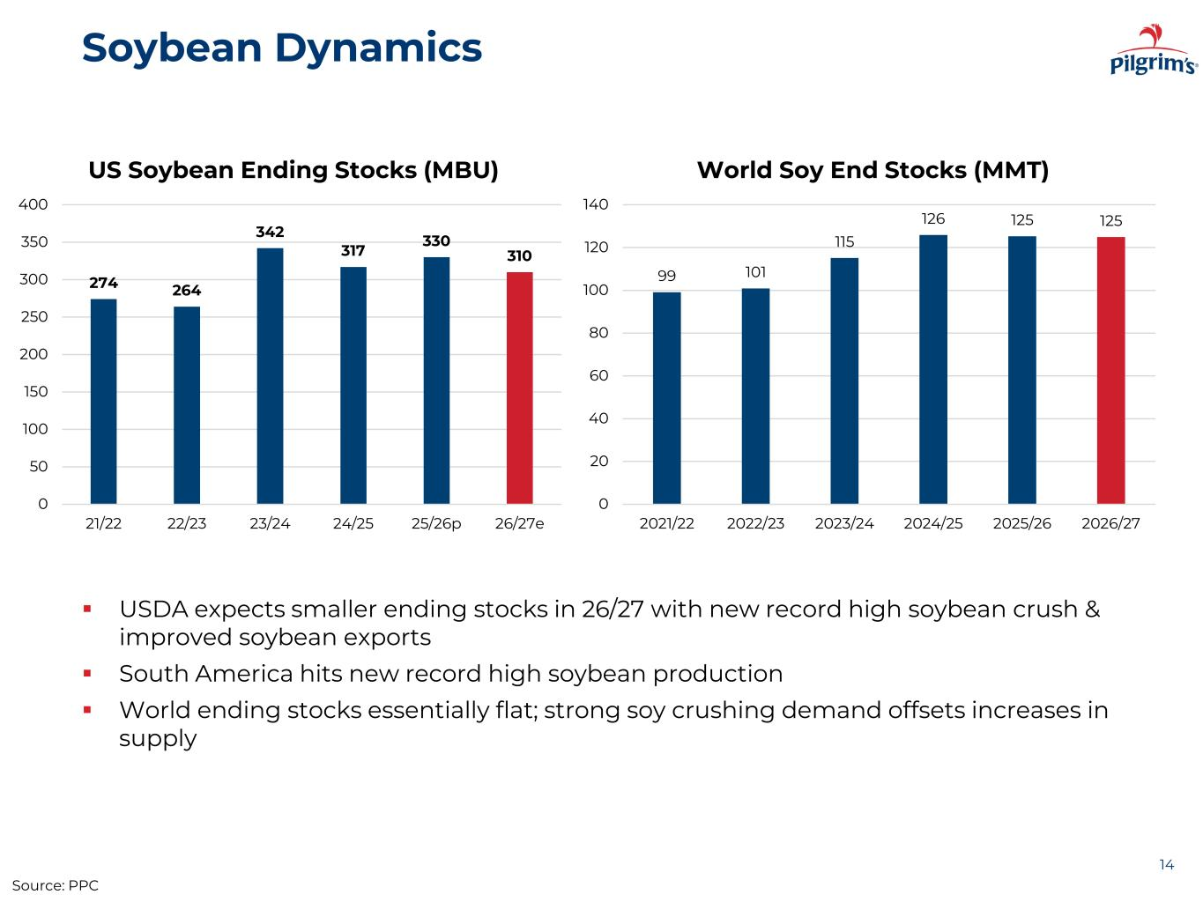
Soybean Dynamics 14 Source: PPC ▪ USDA expects smaller ending stocks in 26/27 with new record high soybean crush & improved soybean exports ▪ South America hits new record high soybean production ▪ World ending stocks essentially flat; strong soy crushing demand offsets increases in supply 99 101 115 126 125 125 0 20 40 60 80 100 120 140 2021/22 2022/23 2023/24 2024/25 2025/26 2026/27 World Soy End Stocks (MMT) 274 264 342 317 330 310 0 50 100 150 200 250 300 350 400 21/22 22/23 23/24 24/25 25/26p 26/27e US Soybean Ending Stocks (MBU)

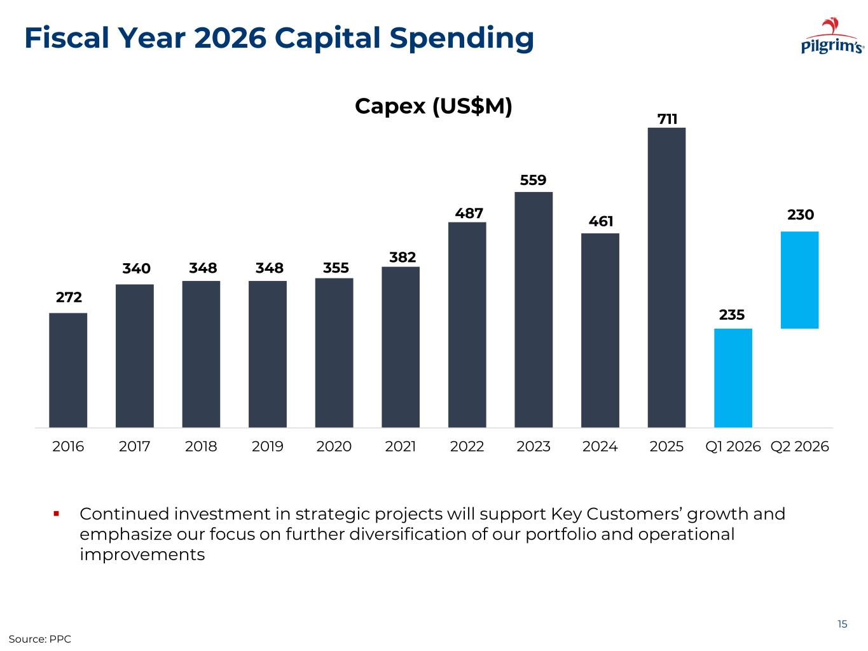
Fiscal Year 2026 Capital Spending 15 Capex (US$M) ▪ Continued investment in strategic projects will support Key Customers’ growth and emphasize our focus on further diversification of our portfolio and operational improvements Source: PPC 272 340 348 348 355 382 487 559 461 711 235 230 2016 2017 2018 2019 2020 2021 2022 2023 2024 2025 Q1 2026 Q2 2026


APPENDIX 16

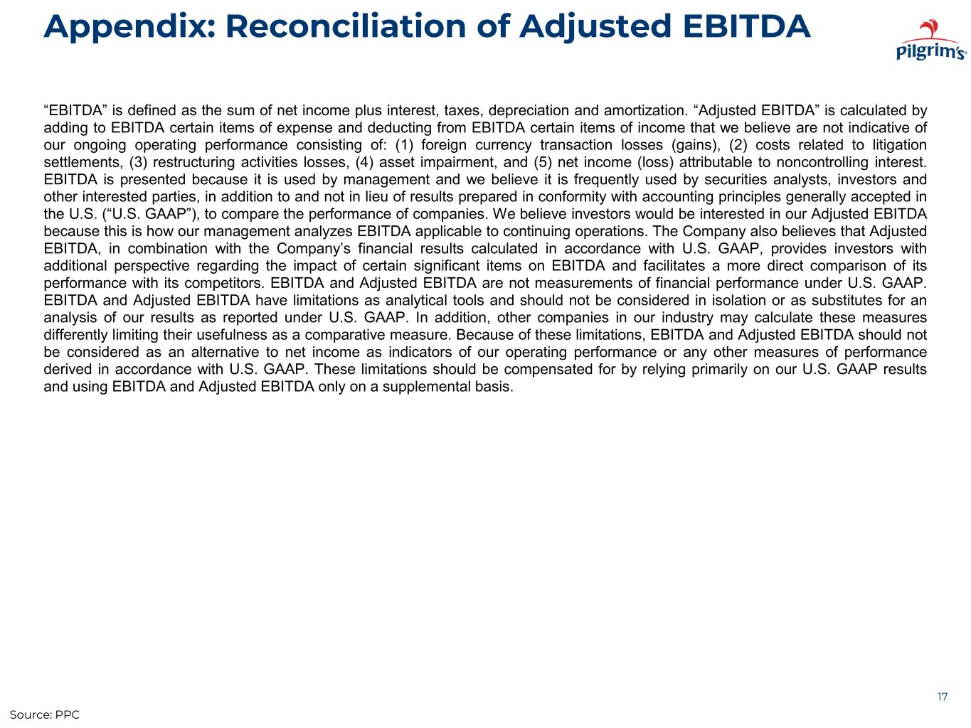
Appendix: Reconciliation of Adjusted EBITDA 17 “EBITDA” is defined as the sum of net income plus interest, taxes, depreciation and amortization. “Adjusted EBITDA” is calculated by adding to EBITDA certain items of expense and deducting from EBITDA certain items of income that we believe are not indicative of our ongoing operating performance consisting of: (1) foreign currency transaction losses (gains), (2) costs related to litigation settlements, (3) restructuring activities losses, (4) asset impairment, and (5) net income (loss) attributable to noncontrolling interest. EBITDA is presented because it is used by management and we believe it is frequently used by securities analysts, investors and other interested parties, in addition to and not in lieu of results prepared in conformity with accounting principles generally accepted in the U.S. (“U.S. GAAP”), to compare the performance of companies. We believe investors would be interested in our Adjusted EBITDA because this is how our management analyzes EBITDA applicable to continuing operations. The Company also believes that Adjusted EBITDA, in combination with the Company’s financial results calculated in accordance with U.S. GAAP, provides investors with additional perspective regarding the impact of certain significant items on EBITDA and facilitates a more direct comparison of its performance with its competitors. EBITDA and Adjusted EBITDA are not measurements of financial performance under U.S. GAAP. EBITDA and Adjusted EBITDA have limitations as analytical tools and should not be considered in isolation or as substitutes for an analysis of our results as reported under U.S. GAAP. In addition, other companies in our industry may calculate these measures differently limiting their usefulness as a comparative measure. Because of these limitations, EBITDA and Adjusted EBITDA should not be considered as an alternative to net income as indicators of our operating performance or any other measures of performance derived in accordance with U.S. GAAP. These limitations should be compensated for by relying primarily on our U.S. GAAP results and using EBITDA and Adjusted EBITDA only on a supplemental basis. Source: PPC

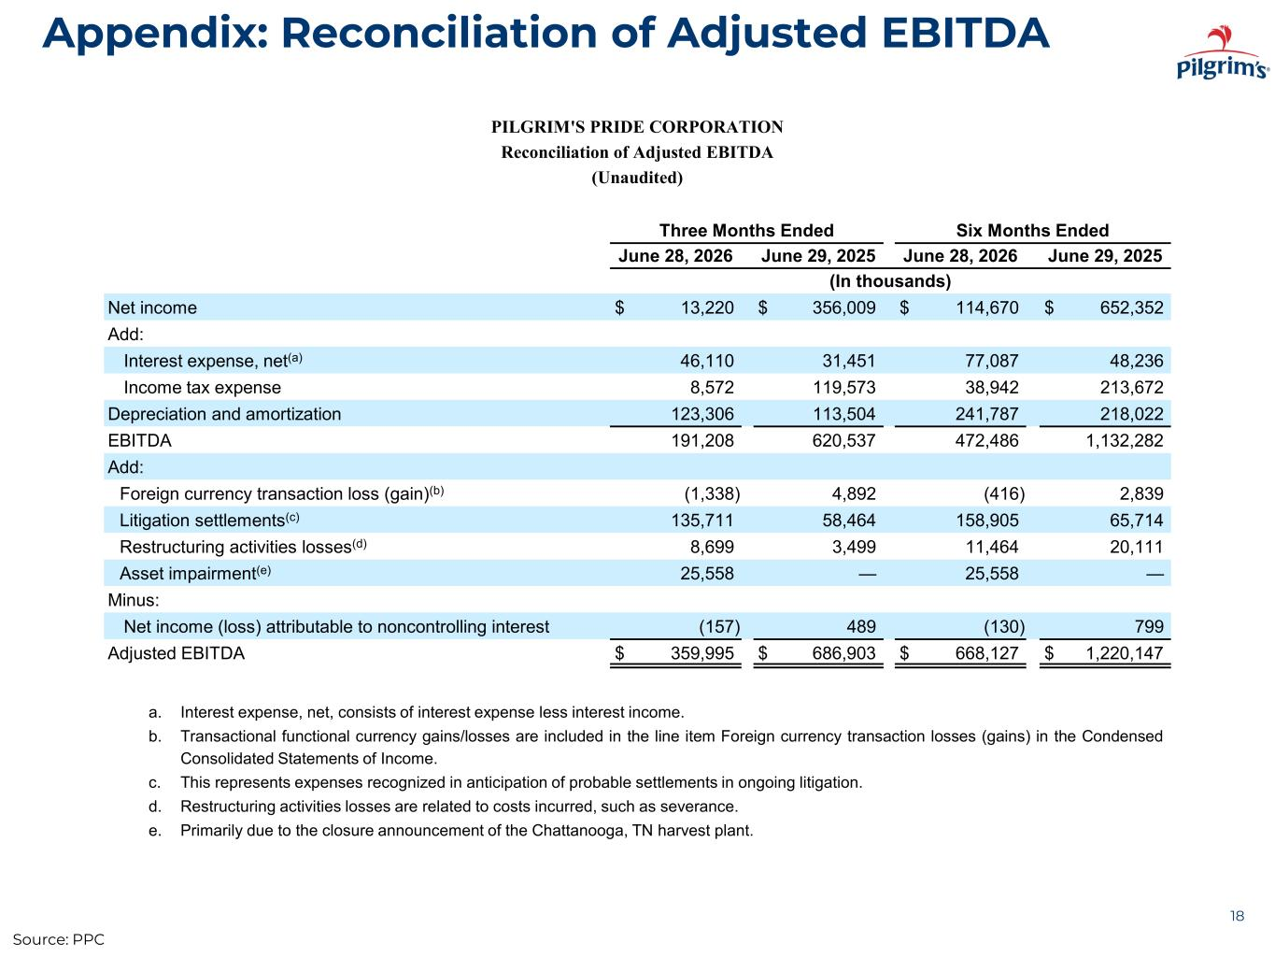
Appendix: Reconciliation of Adjusted EBITDA 18 PILGRIM'S PRIDE CORPORATION Reconciliation of Adjusted EBITDA (Unaudited) Three Months Ended Six Months Ended June 28, 2026 June 29, 2025 June 28, 2026 June 29, 2025 (In thousands) Net income $ 13,220 $ 356,009 $ 114,670 $ 652,352 Add: Interest expense, net(a) 46,110 31,451 77,087 48,236 Income tax expense 8,572 119,573 38,942 213,672 Depreciation and amortization 123,306 113,504 241,787 218,022 EBITDA 191,208 620,537 472,486 1,132,282 Add: Foreign currency transaction loss (gain)(b) (1,338) 4,892 (416) 2,839 Litigation settlements(c) 135,711 58,464 158,905 65,714 Restructuring activities losses(d) 8,699 3,499 11,464 20,111 Asset impairment(e) 25,558 — 25,558 — Minus: Net income (loss) attributable to noncontrolling interest (157) 489 (130) 799 Adjusted EBITDA $ 359,995 $ 686,903 $ 668,127 $ 1,220,147 Source: PPC a. Interest expense, net, consists of interest expense less interest income. b. Transactional functional currency gains/losses are included in the line item Foreign currency transaction losses (gains) in the Condensed Consolidated Statements of Income. c. This represents expenses recognized in anticipation of probable settlements in ongoing litigation. d. Restructuring activities losses are related to costs incurred, such as severance. e. Primarily due to the closure announcement of the Chattanooga, TN harvest plant.

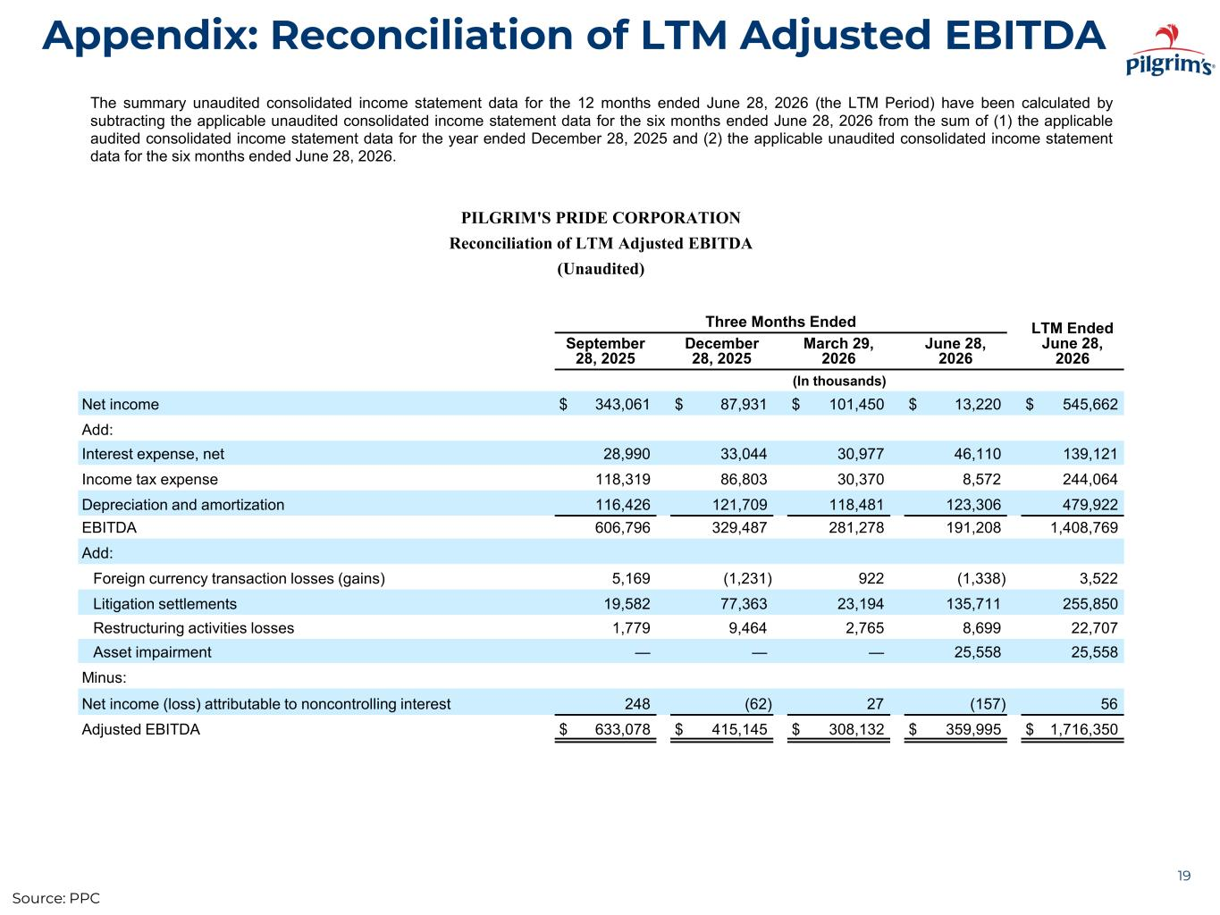
Appendix: Reconciliation of LTM Adjusted EBITDA 19 The summary unaudited consolidated income statement data for the 12 months ended June 28, 2026 (the LTM Period) have been calculated by subtracting the applicable unaudited consolidated income statement data for the six months ended June 28, 2026 from the sum of (1) the applicable audited consolidated income statement data for the year ended December 28, 2025 and (2) the applicable unaudited consolidated income statement data for the six months ended June 28, 2026. PILGRIM'S PRIDE CORPORATION Reconciliation of LTM Adjusted EBITDA (Unaudited) Three Months Ended LTM Ended June 28, 2026 September 28, 2025 December 28, 2025 March 29, 2026 June 28, 2026 (In thousands) Net income $ 343,061 $ 87,931 $ 101,450 $ 13,220 $ 545,662 Add: Interest expense, net 28,990 33,044 30,977 46,110 139,121 Income tax expense 118,319 86,803 30,370 8,572 244,064 Depreciation and amortization 116,426 121,709 118,481 123,306 479,922 EBITDA 606,796 329,487 281,278 191,208 1,408,769 Add: Foreign currency transaction losses (gains) 5,169 (1,231) 922 (1,338) 3,522 Litigation settlements 19,582 77,363 23,194 135,711 255,850 Restructuring activities losses 1,779 9,464 2,765 8,699 22,707 Asset impairment — — — 25,558 25,558 Minus: Net income (loss) attributable to noncontrolling interest 248 (62) 27 (157) 56 Adjusted EBITDA $ 633,078 $ 415,145 $ 308,132 $ 359,995 $ 1,716,350 Source: PPC

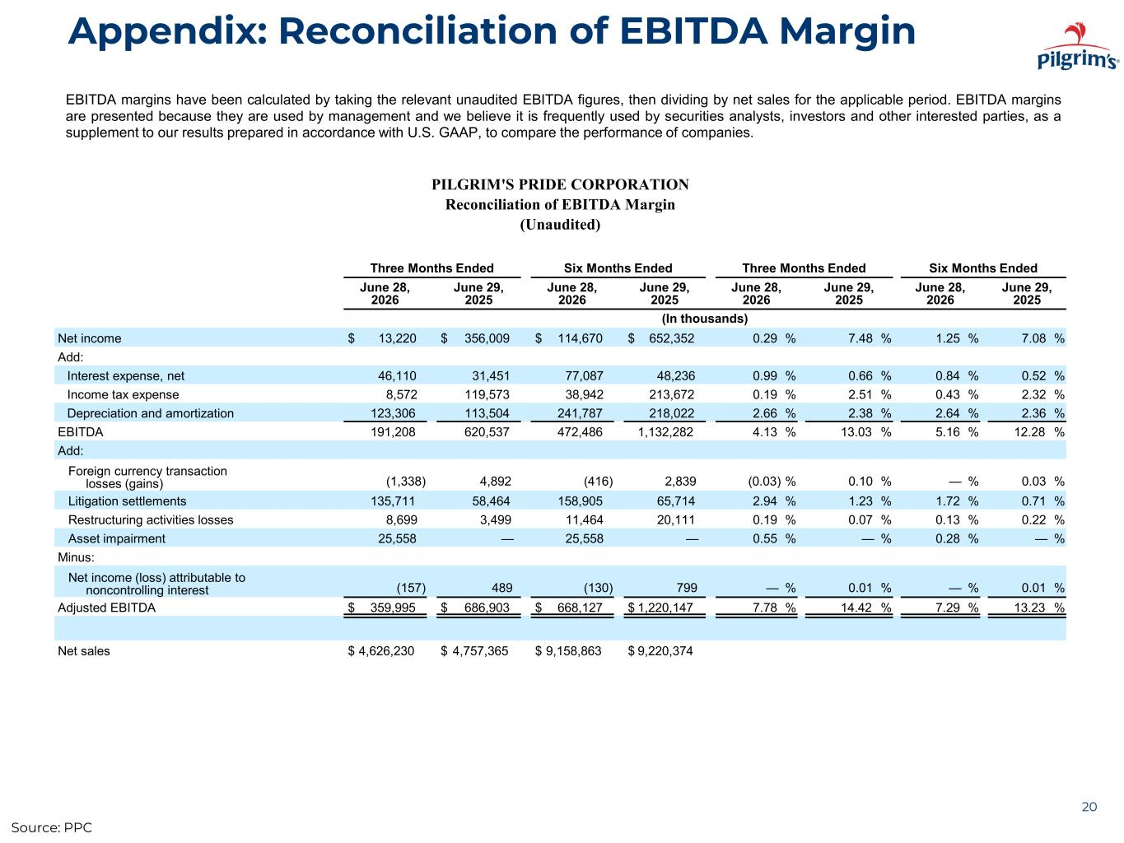
Appendix: Reconciliation of EBITDA Margin 20 EBITDA margins have been calculated by taking the relevant unaudited EBITDA figures, then dividing by net sales for the applicable period. EBITDA margins are presented because they are used by management and we believe it is frequently used by securities analysts, investors and other interested parties, as a supplement to our results prepared in accordance with U.S. GAAP, to compare the performance of companies. PILGRIM'S PRIDE CORPORATION Reconciliation of EBITDA Margin (Unaudited) Three Months Ended Six Months Ended Three Months Ended Six Months Ended June 28, 2026 June 29, 2025 June 28, 2026 June 29, 2025 June 28, 2026 June 29, 2025 June 28, 2026 June 29, 2025 (In thousands) Net income $ 13,220 $ 356,009 $ 114,670 $ 652,352 0.29 % 7.48 % 1.25 % 7.08 % Add: Interest expense, net 46,110 31,451 77,087 48,236 0.99 % 0.66 % 0.84 % 0.52 % Income tax expense 8,572 119,573 38,942 213,672 0.19 % 2.51 % 0.43 % 2.32 % Depreciation and amortization 123,306 113,504 241,787 218,022 2.66 % 2.38 % 2.64 % 2.36 % EBITDA 191,208 620,537 472,486 1,132,282 4.13 % 13.03 % 5.16 % 12.28 % Add: Foreign currency transaction losses (gains) (1,338) 4,892 (416) 2,839 (0.03) % 0.10 % — % 0.03 % Litigation settlements 135,711 58,464 158,905 65,714 2.94 % 1.23 % 1.72 % 0.71 % Restructuring activities losses 8,699 3,499 11,464 20,111 0.19 % 0.07 % 0.13 % 0.22 % Asset impairment 25,558 — 25,558 — 0.55 % — % 0.28 % — % Minus: Net income (loss) attributable to noncontrolling interest (157) 489 (130) 799 — % 0.01 % — % 0.01 % Adjusted EBITDA $ 359,995 $ 686,903 $ 668,127 $ 1,220,147 7.78 % 14.42 % 7.29 % 13.23 % Net sales $ 4,626,230 $ 4,757,365 $ 9,158,863 $ 9,220,374 Source: PPC

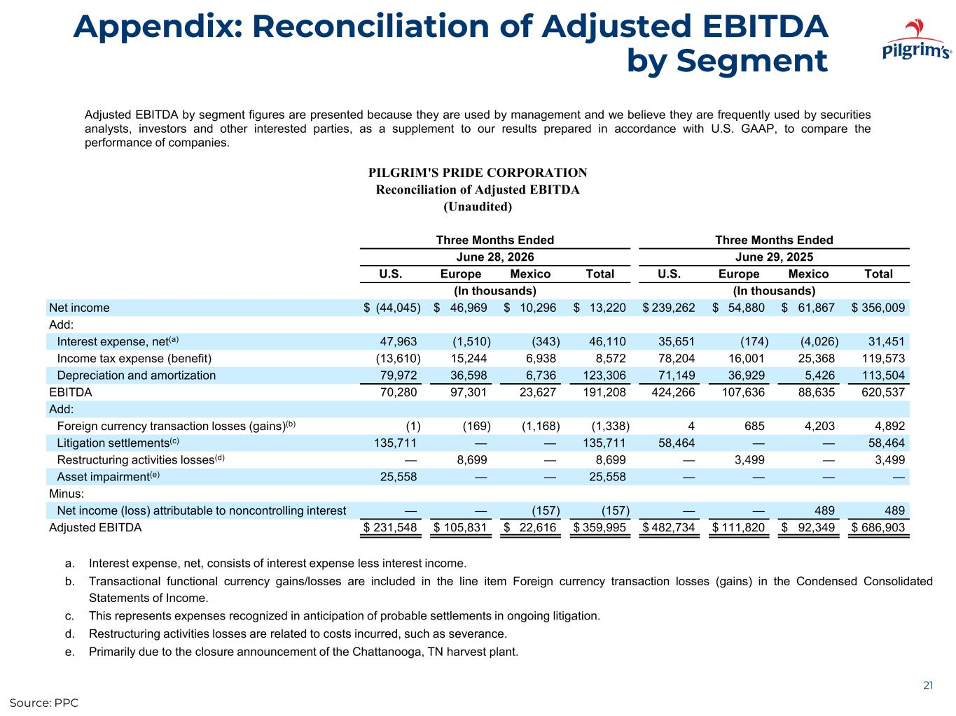
Appendix: Reconciliation of Adjusted EBITDA by Segment 21 PILGRIM'S PRIDE CORPORATION Reconciliation of Adjusted EBITDA (Unaudited) Three Months Ended Three Months Ended June 28, 2026 June 29, 2025 U.S. Europe Mexico Total U.S. Europe Mexico Total (In thousands) (In thousands) Net income $ (44,045) $ 46,969 $ 10,296 $ 13,220 $ 239,262 $ 54,880 $ 61,867 $ 356,009 Add: Interest expense, net(a) 47,963 (1,510) (343) 46,110 35,651 (174) (4,026) 31,451 Income tax expense (benefit) (13,610) 15,244 6,938 8,572 78,204 16,001 25,368 119,573 Depreciation and amortization 79,972 36,598 6,736 123,306 71,149 36,929 5,426 113,504 EBITDA 70,280 97,301 23,627 191,208 424,266 107,636 88,635 620,537 Add: Foreign currency transaction losses (gains)(b) (1) (169) (1,168) (1,338) 4 685 4,203 4,892 Litigation settlements(c) 135,711 — — 135,711 58,464 — — 58,464 Restructuring activities losses(d) — 8,699 — 8,699 — 3,499 — 3,499 Asset impairment(e) 25,558 — — 25,558 — — — — Minus: Net income (loss) attributable to noncontrolling interest — — (157) (157) — — 489 489 Adjusted EBITDA $ 231,548 $ 105,831 $ 22,616 $ 359,995 $ 482,734 $ 111,820 $ 92,349 $ 686,903 Adjusted EBITDA by segment figures are presented because they are used by management and we believe they are frequently used by securities analysts, investors and other interested parties, as a supplement to our results prepared in accordance with U.S. GAAP, to compare the performance of companies. Source: PPC a. Interest expense, net, consists of interest expense less interest income. b. Transactional functional currency gains/losses are included in the line item Foreign currency transaction losses (gains) in the Condensed Consolidated Statements of Income. c. This represents expenses recognized in anticipation of probable settlements in ongoing litigation. d. Restructuring activities losses are related to costs incurred, such as severance. e. Primarily due to the closure announcement of the Chattanooga, TN harvest plant.

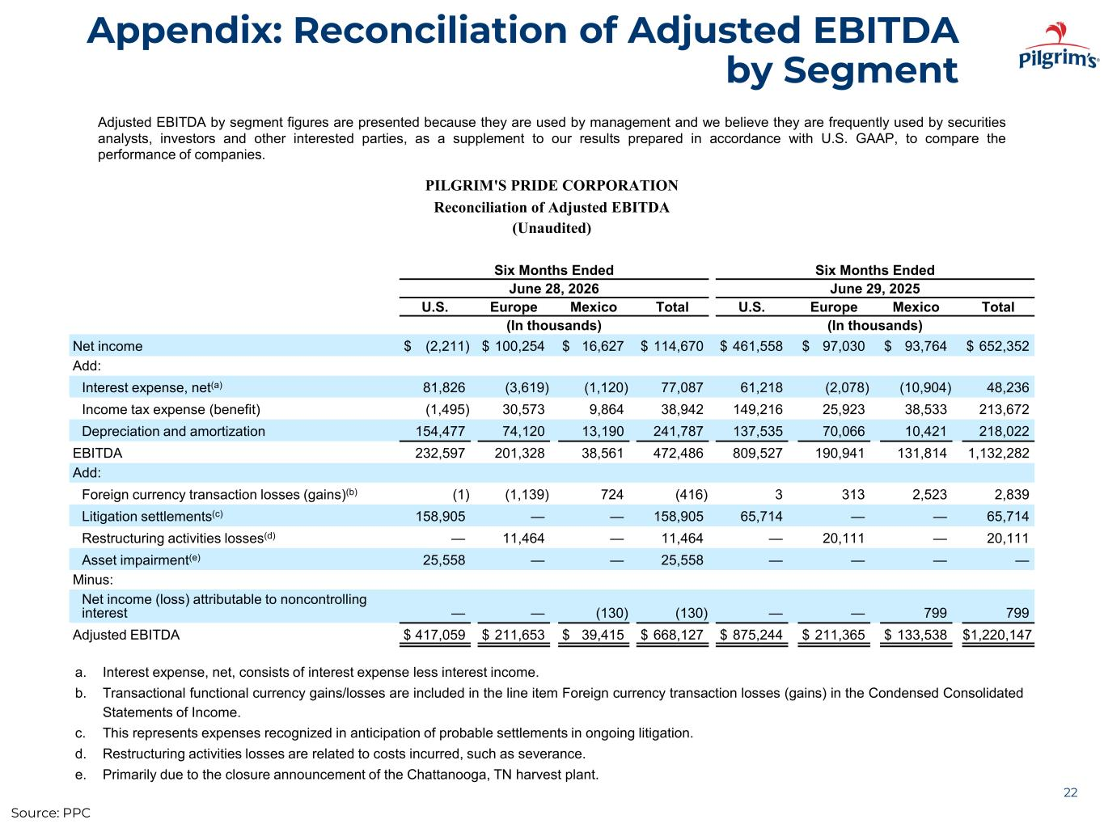
Appendix: Reconciliation of Adjusted EBITDA by Segment 22 PILGRIM'S PRIDE CORPORATION Reconciliation of Adjusted EBITDA (Unaudited) Six Months Ended Six Months Ended June 28, 2026 June 29, 2025 U.S. Europe Mexico Total U.S. Europe Mexico Total (In thousands) (In thousands) Net income $ (2,211) $ 100,254 $ 16,627 $ 114,670 $ 461,558 $ 97,030 $ 93,764 $ 652,352 Add: Interest expense, net(a) 81,826 (3,619) (1,120) 77,087 61,218 (2,078) (10,904) 48,236 Income tax expense (benefit) (1,495) 30,573 9,864 38,942 149,216 25,923 38,533 213,672 Depreciation and amortization 154,477 74,120 13,190 241,787 137,535 70,066 10,421 218,022 EBITDA 232,597 201,328 38,561 472,486 809,527 190,941 131,814 1,132,282 Add: Foreign currency transaction losses (gains)(b) (1) (1,139) 724 (416) 3 313 2,523 2,839 Litigation settlements(c) 158,905 — — 158,905 65,714 — — 65,714 Restructuring activities losses(d) — 11,464 — 11,464 — 20,111 — 20,111 Asset impairment(e) 25,558 — — 25,558 — — — — Minus: Net income (loss) attributable to noncontrolling interest — — (130) (130) — — 799 799 Adjusted EBITDA $ 417,059 $ 211,653 $ 39,415 $ 668,127 $ 875,244 $ 211,365 $ 133,538 $1,220,147 Adjusted EBITDA by segment figures are presented because they are used by management and we believe they are frequently used by securities analysts, investors and other interested parties, as a supplement to our results prepared in accordance with U.S. GAAP, to compare the performance of companies. Source: PPC a. Interest expense, net, consists of interest expense less interest income. b. Transactional functional currency gains/losses are included in the line item Foreign currency transaction losses (gains) in the Condensed Consolidated Statements of Income. c. This represents expenses recognized in anticipation of probable settlements in ongoing litigation. d. Restructuring activities losses are related to costs incurred, such as severance. e. Primarily due to the closure announcement of the Chattanooga, TN harvest plant.

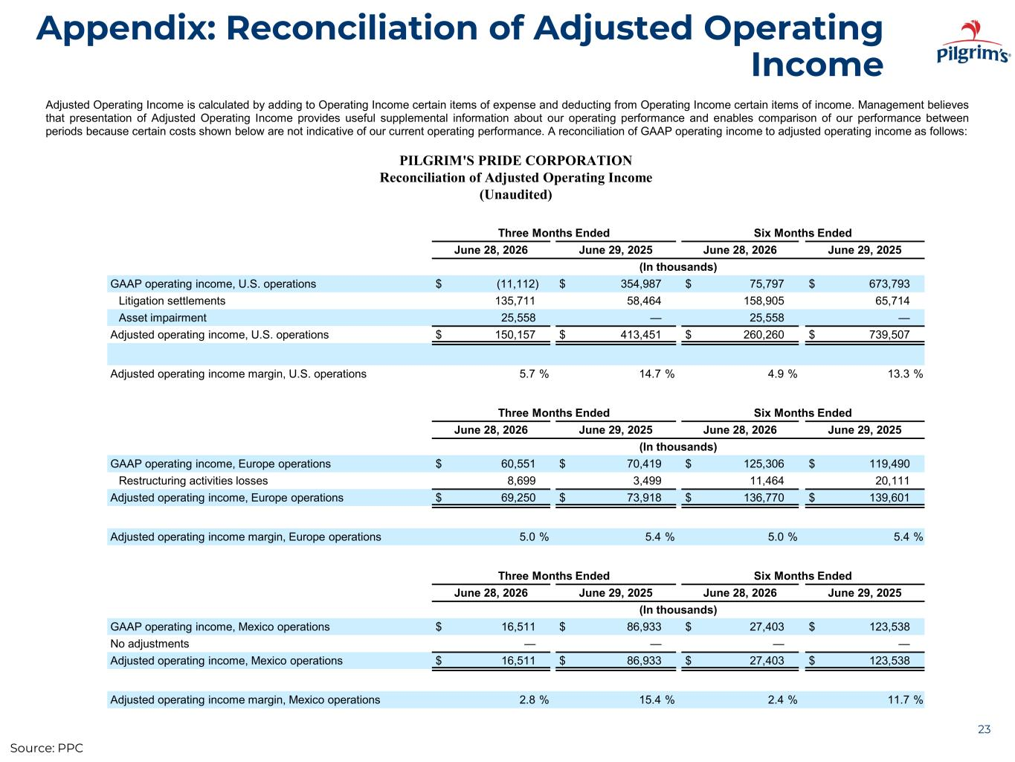
Appendix: Reconciliation of Adjusted Operating Income 23 Adjusted Operating Income is calculated by adding to Operating Income certain items of expense and deducting from Operating Income certain items of income. Management believes that presentation of Adjusted Operating Income provides useful supplemental information about our operating performance and enables comparison of our performance between periods because certain costs shown below are not indicative of our current operating performance. A reconciliation of GAAP operating income to adjusted operating income as follows: PILGRIM'S PRIDE CORPORATION Reconciliation of Adjusted Operating Income (Unaudited) Three Months Ended Six Months Ended June 28, 2026 June 29, 2025 June 28, 2026 June 29, 2025 (In thousands) GAAP operating income, U.S. operations $ (11,112) $ 354,987 $ 75,797 $ 673,793 Litigation settlements 135,711 58,464 158,905 65,714 Asset impairment 25,558 — 25,558 — Adjusted operating income, U.S. operations $ 150,157 $ 413,451 $ 260,260 $ 739,507 Adjusted operating income margin, U.S. operations 5.7 % 14.7 % 4.9 % 13.3 % Three Months Ended Six Months Ended June 28, 2026 June 29, 2025 June 28, 2026 June 29, 2025 (In thousands) GAAP operating income, Europe operations $ 60,551 $ 70,419 $ 125,306 $ 119,490 Restructuring activities losses 8,699 3,499 11,464 20,111 Adjusted operating income, Europe operations $ 69,250 $ 73,918 $ 136,770 $ 139,601 Adjusted operating income margin, Europe operations 5.0 % 5.4 % 5.0 % 5.4 % Three Months Ended Six Months Ended June 28, 2026 June 29, 2025 June 28, 2026 June 29, 2025 (In thousands) GAAP operating income, Mexico operations $ 16,511 $ 86,933 $ 27,403 $ 123,538 No adjustments — — — — Adjusted operating income, Mexico operations $ 16,511 $ 86,933 $ 27,403 $ 123,538 Adjusted operating income margin, Mexico operations 2.8 % 15.4 % 2.4 % 11.7 % Source: PPC

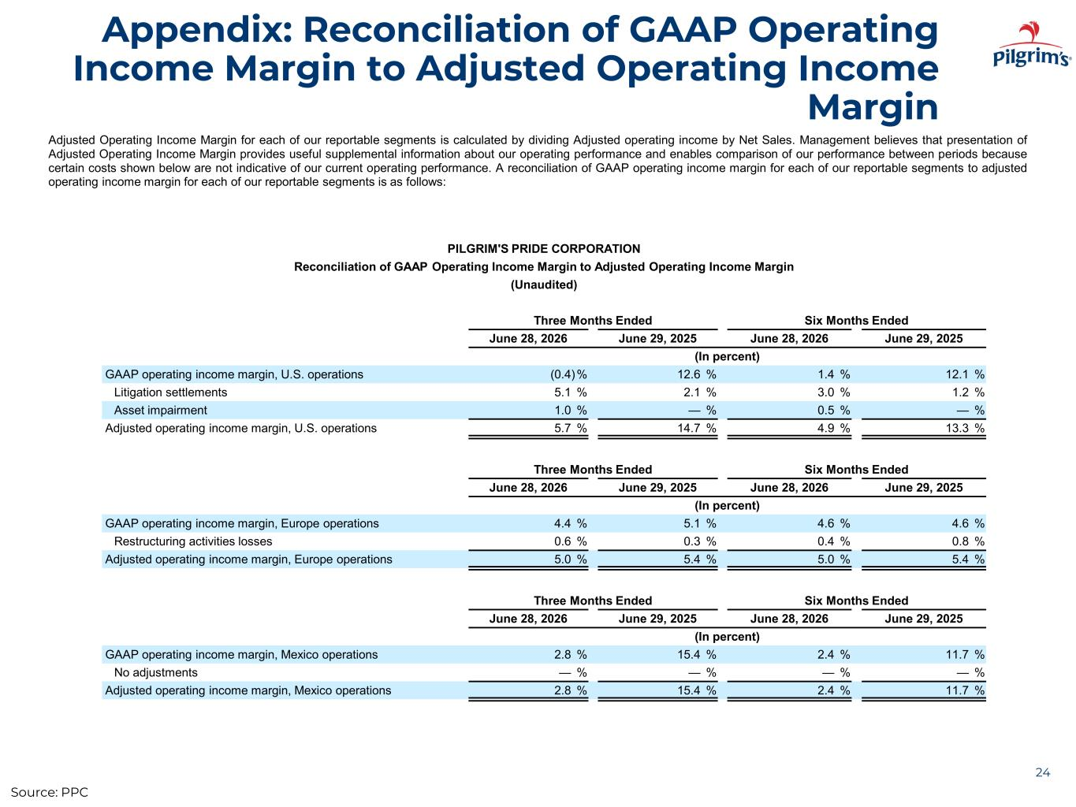
Appendix: Reconciliation of GAAP Operating Income Margin to Adjusted Operating Income Margin 24 Adjusted Operating Income Margin for each of our reportable segments is calculated by dividing Adjusted operating income by Net Sales. Management believes that presentation of Adjusted Operating Income Margin provides useful supplemental information about our operating performance and enables comparison of our performance between periods because certain costs shown below are not indicative of our current operating performance. A reconciliation of GAAP operating income margin for each of our reportable segments to adjusted operating income margin for each of our reportable segments is as follows: PILGRIM'S PRIDE CORPORATION Reconciliation of GAAP Operating Income Margin to Adjusted Operating Income Margin (Unaudited) Three Months Ended Six Months Ended June 28, 2026 June 29, 2025 June 28, 2026 June 29, 2025 (In percent) GAAP operating income margin, U.S. operations (0.4)% 12.6 % 1.4 % 12.1 % Litigation settlements 5.1 % 2.1 % 3.0 % 1.2 % Asset impairment 1.0 % — % 0.5 % — % Adjusted operating income margin, U.S. operations 5.7 % 14.7 % 4.9 % 13.3 % Three Months Ended Six Months Ended June 28, 2026 June 29, 2025 June 28, 2026 June 29, 2025 (In percent) GAAP operating income margin, Europe operations 4.4 % 5.1 % 4.6 % 4.6 % Restructuring activities losses 0.6 % 0.3 % 0.4 % 0.8 % Adjusted operating income margin, Europe operations 5.0 % 5.4 % 5.0 % 5.4 % Three Months Ended Six Months Ended June 28, 2026 June 29, 2025 June 28, 2026 June 29, 2025 (In percent) GAAP operating income margin, Mexico operations 2.8 % 15.4 % 2.4 % 11.7 % No adjustments — % — % — % — % Adjusted operating income margin, Mexico operations 2.8 % 15.4 % 2.4 % 11.7 % Source: PPC

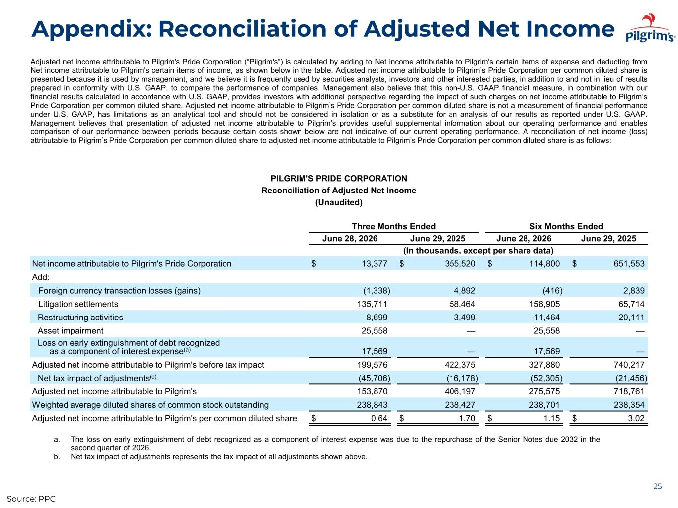
Appendix: Reconciliation of Adjusted Net Income 25 Adjusted net income attributable to Pilgrim's Pride Corporation (“Pilgrim's”) is calculated by adding to Net income attributable to Pilgrim's certain items of expense and deducting from Net income attributable to Pilgrim's certain items of income, as shown below in the table. Adjusted net income attributable to Pilgrim’s Pride Corporation per common diluted share is presented because it is used by management, and we believe it is frequently used by securities analysts, investors and other interested parties, in addition to and not in lieu of results prepared in conformity with U.S. GAAP, to compare the performance of companies. Management also believe that this non-U.S. GAAP financial measure, in combination with our financial results calculated in accordance with U.S. GAAP, provides investors with additional perspective regarding the impact of such charges on net income attributable to Pilgrim’s Pride Corporation per common diluted share. Adjusted net income attributable to Pilgrim’s Pride Corporation per common diluted share is not a measurement of financial performance under U.S. GAAP, has limitations as an analytical tool and should not be considered in isolation or as a substitute for an analysis of our results as reported under U.S. GAAP. Management believes that presentation of adjusted net income attributable to Pilgrim’s provides useful supplemental information about our operating performance and enables comparison of our performance between periods because certain costs shown below are not indicative of our current operating performance. A reconciliation of net income (loss) attributable to Pilgrim’s Pride Corporation per common diluted share to adjusted net income attributable to Pilgrim’s Pride Corporation per common diluted share is as follows: PILGRIM'S PRIDE CORPORATION Reconciliation of Adjusted Net Income (Unaudited) Three Months Ended Six Months Ended June 28, 2026 June 29, 2025 June 28, 2026 June 29, 2025 (In thousands, except per share data) Net income attributable to Pilgrim's Pride Corporation $ 13,377 $ 355,520 $ 114,800 $ 651,553 Add: Foreign currency transaction losses (gains) (1,338) 4,892 (416) 2,839 Litigation settlements 135,711 58,464 158,905 65,714 Restructuring activities 8,699 3,499 11,464 20,111 Asset impairment 25,558 — 25,558 — Loss on early extinguishment of debt recognized as a component of interest expense(a) 17,569 — 17,569 — Adjusted net income attributable to Pilgrim's before tax impact 199,576 422,375 327,880 740,217 Net tax impact of adjustments(b) (45,706) (16,178) (52,305) (21,456) Adjusted net income attributable to Pilgrim's 153,870 406,197 275,575 718,761 Weighted average diluted shares of common stock outstanding 238,843 238,427 238,701 238,354 Adjusted net income attributable to Pilgrim's per common diluted share $ 0.64 $ 1.70 $ 1.15 $ 3.02 a. The loss on early extinguishment of debt recognized as a component of interest expense was due to the repurchase of the Senior Notes due 2032 in the second quarter of 2026. b. Net tax impact of adjustments represents the tax impact of all adjustments shown above. Source: PPC

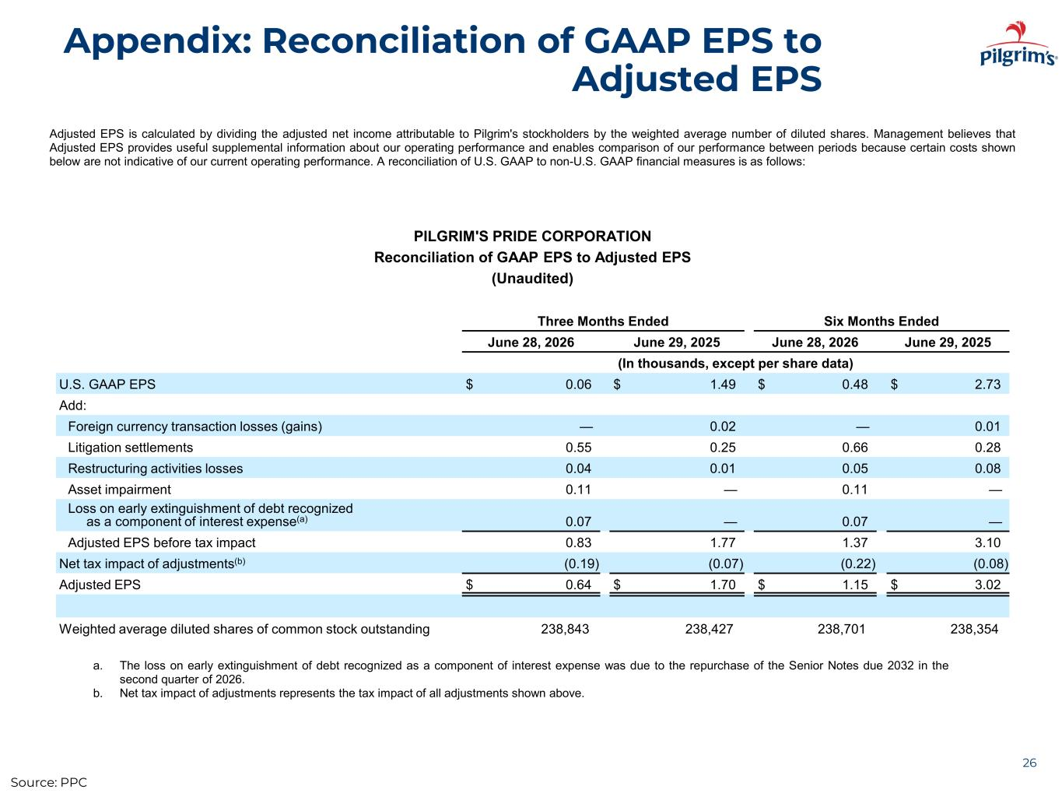
Appendix: Reconciliation of GAAP EPS to Adjusted EPS 26 Adjusted EPS is calculated by dividing the adjusted net income attributable to Pilgrim's stockholders by the weighted average number of diluted shares. Management believes that Adjusted EPS provides useful supplemental information about our operating performance and enables comparison of our performance between periods because certain costs shown below are not indicative of our current operating performance. A reconciliation of U.S. GAAP to non-U.S. GAAP financial measures is as follows: PILGRIM'S PRIDE CORPORATION Reconciliation of GAAP EPS to Adjusted EPS (Unaudited) Three Months Ended Six Months Ended June 28, 2026 June 29, 2025 June 28, 2026 June 29, 2025 (In thousands, except per share data) U.S. GAAP EPS $ 0.06 $ 1.49 $ 0.48 $ 2.73 Add: Foreign currency transaction losses (gains) — 0.02 — 0.01 Litigation settlements 0.55 0.25 0.66 0.28 Restructuring activities losses 0.04 0.01 0.05 0.08 Asset impairment 0.11 — 0.11 — Loss on early extinguishment of debt recognized as a component of interest expense(a) 0.07 — 0.07 — Adjusted EPS before tax impact 0.83 1.77 1.37 3.10 Net tax impact of adjustments(b) (0.19) (0.07) (0.22) (0.08) Adjusted EPS $ 0.64 $ 1.70 $ 1.15 $ 3.02 Weighted average diluted shares of common stock outstanding 238,843 238,427 238,701 238,354 a. The loss on early extinguishment of debt recognized as a component of interest expense was due to the repurchase of the Senior Notes due 2032 in the second quarter of 2026. b. Net tax impact of adjustments represents the tax impact of all adjustments shown above. Source: PPC

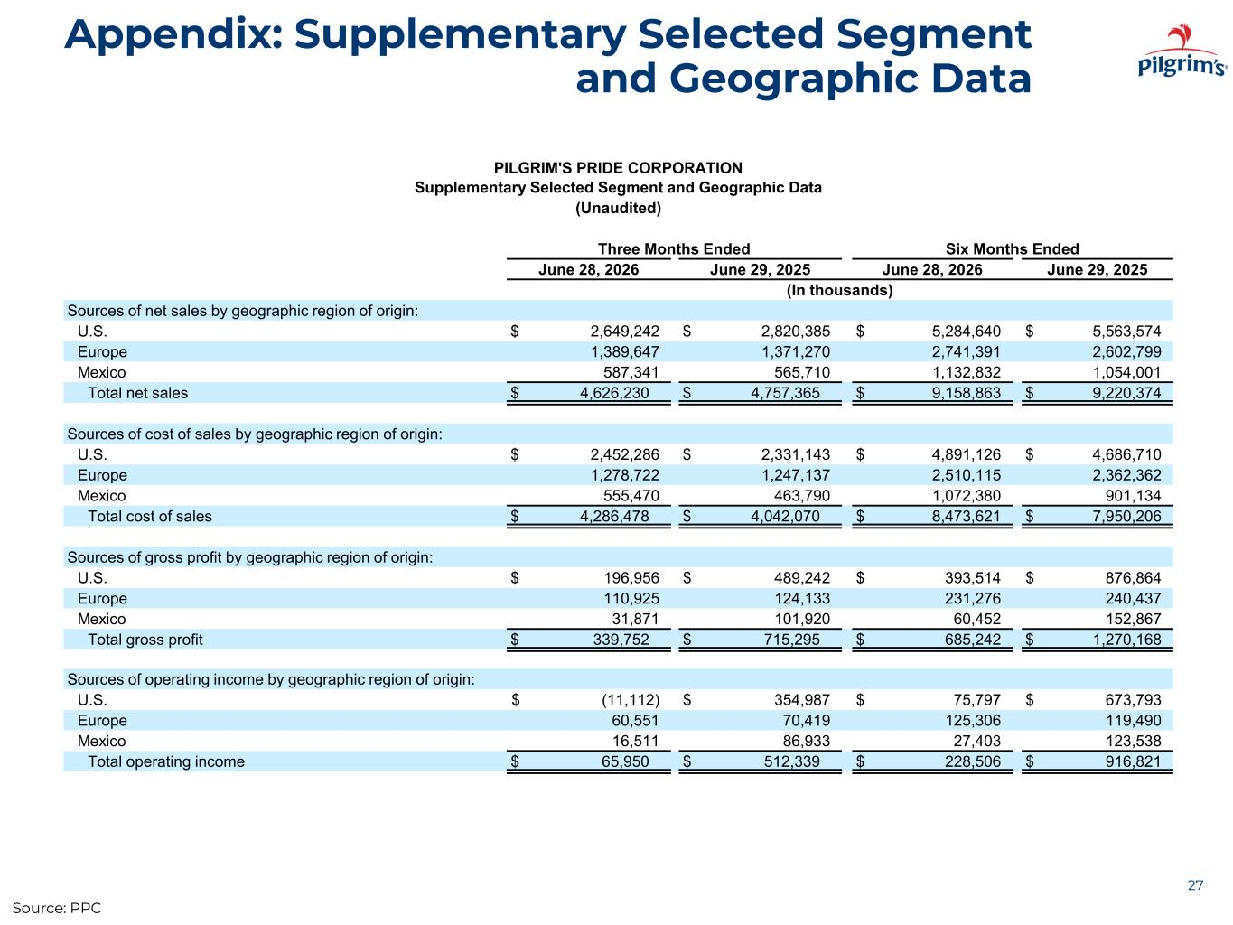
Appendix: Supplementary Selected Segment and Geographic Data 27 PILGRIM'S PRIDE CORPORATION Supplementary Selected Segment and Geographic Data (Unaudited) Three Months Ended Six Months Ended June 28, 2026 June 29, 2025 June 28, 2026 June 29, 2025 (In thousands) Sources of net sales by geographic region of origin: U.S. $ 2,649,242 $ 2,820,385 $ 5,284,640 $ 5,563,574 Europe 1,389,647 1,371,270 2,741,391 2,602,799 Mexico 587,341 565,710 1,132,832 1,054,001 Total net sales $ 4,626,230 $ 4,757,365 $ 9,158,863 $ 9,220,374 Sources of cost of sales by geographic region of origin: U.S. $ 2,452,286 $ 2,331,143 $ 4,891,126 $ 4,686,710 Europe 1,278,722 1,247,137 2,510,115 2,362,362 Mexico 555,470 463,790 1,072,380 901,134 Total cost of sales $ 4,286,478 $ 4,042,070 $ 8,473,621 $ 7,950,206 Sources of gross profit by geographic region of origin: U.S. $ 196,956 $ 489,242 $ 393,514 $ 876,864 Europe 110,925 124,133 231,276 240,437 Mexico 31,871 101,920 60,452 152,867 Total gross profit $ 339,752 $ 715,295 $ 685,242 $ 1,270,168 Sources of operating income by geographic region of origin: U.S. $ (11,112) $ 354,987 $ 75,797 $ 673,793 Europe 60,551 70,419 125,306 119,490 Mexico 16,511 86,933 27,403 123,538 Total operating income $ 65,950 $ 512,339 $ 228,506 $ 916,821 Source: PPC

